THE KYRGYZ REPUBLIC

Ministry of Education and Science

Quarterly report
Enhancing the Foundation of Learning Project

Quarter 2, 2023

August-2023

INTRODUCTION

1. Background
In 2018, the President of the Republic approved the ‘National Development Strategy for 2018-2040 (Strategy 2040). Its focus is to create opportunities for human capital development including through education and the creation of highly-productive quality jobs, particularly in strategic sectors. It is fully aligned with the Sustainable Development Goals (SDGs). The first phase of the Strategy 2040, the ‘Development Program of the KR 2018-22 (Program 22)’ acknowledges that the education system is not yet effective in developing the higher order skills that are needed; and identifies several education sector priorities, including: (i) improving the quality of education; (ii) making the education system more effective in teaching skills required by the modern economy; (iii) supplying schools with a broader range of modern teaching-learning materials and innovative technology and (iv) strengthening the professional capacities of teachers. In the latest development, the MoES’s draft of the National Education Sector Strategy 2030 addresses on the following priorities: (i) expanding access to ECE and improving its quality; (ii) strengthening teacher professional capacities to effectively teach skills, including transversal competencies (such as digital literacy) and providing flexible, accessible and affordable continuous professional development; (iii) improving the availability and use of digital teaching-learning materials at schools; and (iv) strengthening assessment systems to ensure children are formatively assessed, summative assessments are aligned with curricular competencies, and sample-based learning outcome evaluations are carried out to identify and remedy system weaknesses.
This report describes the social and environmental activities of the project from April to June 2023.
Environmental and social issues include activities undertaken to manage and minimize adverse environmental and social impacts during implementation of sub-projects of the Enhancing the Foundation of Learning project. In accordance with the environmental and social standards of the World Bank, the procedures and mechanisms necessary for the implementation of appropriate project activities to the standards of the WB, as well as the legal and regulatory acts of the Kyrgyz Republic are covered.
Basis and date of entry into force of the Enhancing the Foundation of Learning Project – The Kyrgyz Republic and the International Development Association signed the Loan Agreement for the Enhancing the Foundation of Learning Project dated July 13, 2021, this Agreement was ratified by the Zhogorku Kenesh of the Kyrgyz Republic on July 29, 2021.
1.1. Project Description
The project objective is to increase equitable access to pre-school education, and to establish conditions for improving its quality. The pre-school institution and its enabling environment are at the core of the project. The project will use a multi-pronged approach that includes three components and several sub-components, as described below.
The pre-school institution and its enabling environment are at the core of The Project. It has two complementary components, as well as an implementation support component.
The first component focuses on enhancing access to quality pre-school education, targeting the poor and vulnerable including minority ethnic groups and children with special education needs. The second component focuses on improving policy, programs and system effectiveness. Successful implementation of these two components would eventually contribute to improved learning outcomes of basic schooling for all.
The third component finances advocacy and communication efforts, monitoring and evaluation and the operating cost to support implementation.

The project consists of 3 components and 5 sub-components.

Component 1: Expanding preschool education for under-served children. The aim of this component is to increase equitable access to early education services that meet quality standards for under-served children in targeted communities.
Sub-component 1.1: Expanded preschool education. The objective of this sub-component is to increase equitable access to quality ECE in poor rural areas with no or low access through establishing CbKs and enhance the effectiveness of teaching-learning practices in preschool. The project will support the establishment of about 60 new CbKs enrolling approximately 5,000 children aged 3–5 years.
Sub-component 1.2: Increased effectiveness in teaching practice. The objective of this subcomponent is to increase teacher capacities in preschool education through the strengthened design and delivery of teacher training programs aligned to the recently approved child development standards and evidence from the science of learning.

Component 2: Improving policy & finance for the system effectiveness. The objective of this component is to improve policy and system effectiveness.

Component 3: Ensuring citizens’ engagement and implementation support.
The objective of this component is to ensure that all stakeholders are engaged in project implementation and monitoring.
Sub-component 3.1: Stakeholders’ engagement. Stakeholders will be engaged in the implementation of activities across the project, building on the mechanisms already in place to involve parents, particularly fathers, and community members. Specifically, this includes: (a) the provision of information for parents on importance of early development of children, story books reading through leaflets, posters, guidance on story books reading importance and techniques, etc.; and (b) community monitoring through community scorecards.
Sub-component 3.2: Evaluation. To assess the project impact, an evaluation using Randomized Control Trials (RCT) will be conducted to determine if participation in the project supported CbKs had an impact on child development.
Sub-component 3.3: Implementation support. This component will support the coordination, technical quality and fiduciary integrity, compliance with environmental and social standards in due course of implementation, as well as the monitoring, evaluation and reporting on project processes and results. It will also support systems for collecting beneficiary feedback to inform project implementation.
2. MONITORING AND REPORTING

The Enhancing the Foundation of Learning project focuses on monitoring and reporting according to approved project implementation plans, compliance with socio-environmental standards, stakeholder engagement plan, labor management procedures, socio-environmental commitment plan, environmental and social management plan, grievance mechanisms, and sexual exploitation and abuse/sexual harassment.
During the reporting period, no incidents or accidents within the framework of the Enhancing the Foundation of Learning project were reported.

3. LEGAL AND REGULATORY ACTS ADOPTED AS PART OF THE IMPLEMENTATION OF THE ENHANCING THE FOUNDATION OF LEARNING PROJECT
3.1. In order to achieve the goals and objectives of the Enhancing the Foundation of Learning project, the following legal and regulatory documentation was prepared and adopted:
- Order of the Ministry of Education and Science of the Kyrgyz Republic #1980/1 of 19.11.2021 "On approval of the Regulation on criteria for selection of 60 short-term (3-hour) stay preschool education centers in the Kyrgyz Republic";
- Order of the Ministry of Education and Science of the Kyrgyz Republic #397/1 of 18.03.2022 "On formation of the permanent commission on selection of community-based kindergartens/preschool education centers";
- Order of the Ministry of Education and Science of the Kyrgyz Republic #398 of 18.03.2022 "On introducing amendments to the Regulation on criteria for selection of 60 short-term (3-hour) stay preschool education centers in the Kyrgyz Republic";
- Order of the Ministry of Education and Science of the Kyrgyz Republic #1429/1 of 14.07.2022 "On approval of the preliminary list of newly selected buildings for establishment of 60 community-based kindergartens/preschool education centers";
- Order of the Ministry of Education and Science of the Kyrgyz Republic #1303/1/1/1 of 01.07.2022 "On accounting of inventories" including quality control of inventories to ensure the safety of children;
- Grievance mechanism for Projects Coordination Unit (PCU) staff and contract specialists approved by the Deputy Minister of Education and Science of KR;
- Order of the World Bank Projects Implementation/Coordination Unit #01/87 of 22.11.2022 "On Approval of the Code of Business Conduct and Ethics of PIU/PCU".

3.2. Status of the project activities
Component 1. Expanding preschool education for under-served children.
For the reporting period:
- As of this period during the project implementation, tender procedures for repair and rehabilitation works in 29 (twenty-nine) CbKs have been finalized.
- The won contracting organizations are currently preparing 29 (twenty-nine) CbKs for repair and rehabilitation works.
- Alay rayon – 3 facilities (Sopu-Korgon village, "Kyzgaldak koktomu" kindergarten, School No. 35, Sary-Tash village, "Altyn Beshik" kindergarten No. 15);
- Aravan rayon – 2 facilities (Chogom village, School No. 4 named after "Chogom", Kochubaev village, "Nariste" kindergarten);
- Kara-Kulzha rayon – 2 facilities (Sary-Kamysh village, "Bala kyyal" kindergarten, Kara-Kochkor village, building of kindergarten);
- Bazar-Korgon rayon – 3 facilities (Bazar-Korgon town, #2 "Zhomok" kindergraten, Bazar-Korgon town, "Cholpon" kindergarten, Shadyr village - #29 "Burul Ene" kindergarten;
- Nooken rayon – 2 facilities (Uuruzhar village, School No.47 named after A. Tashiev, Kyzyl-Kyya village School No. 24 named after O. Kayypov);
- Suzak rayon – 4 facilities (Zhany-Zher village, School №33 "Zhyide", Lenin village, Taygaraev str. 2 kindergarten, Zherge-Tal village, "Kyzgaldak" kindergarten, Taran-Baza village, building of the kindergarten);
- Alamedin rayon – 2 facilities (Chokmorov village, School named after S. Chokmorov, Polevoi village, Trudovaya str.);
- Kemin rayon – 2 facilities (Podgornyi village, "Podgornyi" kindergarten, Kemin city, "Kasiet" kindergarten);
- Panfilov rayon – 1 facility (Kayindy town, Kanykei str. 24);
- Issyk-Ata rayon – 4 facilities (Toguz-Bulak village, Murzaliev School, Otogon village, Alybaev School, St. Ivanovka village, school № 4, Sadovoe village, school);
- Jety-Oguz rayon – 1 facility (Jety-Oguz village);
- Naryn+At-Bashy rayons – 3 facilities (Ottuk village - Ata-Bala kindergarten, Kuibyshev village - S.Usupov kindergarten, At-Bashy village, "Ak Bairak" kindergarten).
Component 3. Ensuring citizens’ engagement and implementation support.
For the reporting period:
- Awareness raising campaign and meetings with stakeholders (heads of regional and city educational departments, staff of regional and city educational departments, directors, kindergarten teachers (sub-component 1.1. of the Enhancing the Foundation of Learning project) in Chui (Alamedin, Panfilov, Issyk-Ata regions) and Talas oblasts (Talas, Manas, Kara-Buura regions) were conducted;
- Consultations and joint activity with heads and responsible coordinators of the regional and city educational departments (46 regions of the country) on informing stakeholders and on the stages of repair and rehabilitation works in CbKs are conducting on a regular basis through WhatsApp groups.
- Awareness raising campaign with heads of the regional and city educational departments, staff of the regional and city educational departments on formation of lists of teachers for trainings.

4. ESS 1: ENVIRONMENTAL AND SOCIAL RISK AND IMPACT ASSESSMENT AND PREVENTION:
To ensure the implementation of the project in accordance with the Environmental and Social Commitment Plan, socio-environmental standards and other environmental and social instruments, a number of activities were conducted during the reporting period.
4.1. Organizational structure
During the reporting period, there were no changes in the organizational structure and the activity is being performed by the current PCU staff.
  - Selection mechanisms
According to the criteria for selecting buildings for the establishment of 60 (CbKs), priority areas (cities/towns) for selection and participation in the project are:
- areas (small towns) with low income;
- areas (small towns) with a low level of enrollment of children in preschool education;
- border, high-mountain and remote areas (small towns) with low incomes and coverage of children with preschool education;
- areas (small towns) inhabited by ethnic minorities, internal and external migrants.
Children with disabilities, children from poor households with limited educational opportunities, children of migrants and disadvantaged populations, children with physical disabilities will be included in the categories of children to be taught in the CbKs:
- Letters to 46 REDs on preparation of quantitative indicators of students from socially disadvantaged backgrounds have been drafted as part of the implementation of the SEP;
- Consultation was conducted with coordinators of 46 rayons on the need to form lists of students from socially disadvantaged groups in CbKs;
- It is planned to form quantitative information of students from socially disadvantaged groups, by regions and oblasts.
4.3. Transparent procedures and processes for selecting communities to engage in the project have been developed and implemented:
- Premises (based on schools, kindergartens, village first-aid stations (FAPs), clubs, offices, etc.);
- Documents of title for the provided building (technical passport, document of title);
- Letter of guarantee from aiyl okmotu addressed to the Minister stating that the provided premises will be used for 10 years;
- Letter from the regional state administration addressed to the Minister stating that they support this project and agree to participate in this project;
- Letter of guarantee from the regional educational departments stating that the salaries of future teachers will be included in the republican budget;
- Number of out-of-school children from 3 to 7 (waiting in line);
- Consent of the sanitary and epidemiological station (to the opening a kindergarten in provided premise/building);
- Consent of the Ministry of Emergency Situations (documentary evidence);
- Photos of the premises.

In total, out of 90 applications throughout the country, 60 CbKs were selected according to the above criteria(Table 1):
In accordance with the procedures for tenders for the repair and rehabilitation, the bids submitted for the tender are systematically evaluated and the final list of all facilities is constantly adjusted.

4.4. Principles of environmental and social management
In Q2 2023, screening was conducted (Table 2) at facilities in Talas and Chui oblasts. Total percentage of screenings conducted is 100% (Pictures 1,2).

4.5. Environmental and social screening and ESMP
During the reporting year, 2 face-to-face and 3 online (via phone and WhatsApp messenger) consultations of heads and staff of educational departments in Talas and Chui oblasts were conducted regarding the application of environmental and social standards in the process of designing facilities, commencing the construction of short-term kindergartens, providing lists of children from socially vulnerable groups of the background.
In the framework of the Enhancing the Foundation of Learning project, drafting the ESMPs for facilities in accordance with the project implementation plan is underway.
During the reporting period, 29 ESMPs were drafted under the Enhancing the Foundation of Learning project (Alai, Aravan, Kara-Kulja, Bazar-Korgon, Nooken, Suzak, Issyk-Ata, Naryn, At-Bashy, Alamedin, Panfilov, Kemin, Jeti-Oguz regions). The final versions of the ESMPs are posted on the MoES KR website.

5. ESS 2: HUMAN RESOURCES AND WORKING CONDITIONS
The Enhancing the Foundation of Learning project is implemented in accordance with regulations and, in particular, labor management procedures adopted and approved by the World Bank, in order to meet socio-environmental standards.
The direct employees of the project implementation unit are 15 people, and contract employees are 9 people.
5.1. Human resources management procedure
- In June 2023, the Code of Business Conduct and Ethics was signed by representatives of the following companies: AC consulting, EDNET, which conduct training for kindergarten teachers.
- The Code of Business Conduct and Ethics is being signed with contractors.

5.2. Project staff training
According to the implementation of environmental and social commitment plan, information, implementation of the project and in order to conduct trainings for PIU/PCU key staff members, contract specialists and contractors the collection of information materials to do a presentation and videos on social issues (information on safety, health, health safety, prevention of gender-based violence and discrimination, first aid, labor relations, COVID 19) was completed.
During the reporting period it was prepared:
- 1 animated video on COVID-19 disease prevention;
- 1 animated video on safety mechanism of CbKs;
- 1 presentation on grievance mechanism;
- 1 presentation on COVID-19 prevention.
Trainings are scheduled to be held in Q3 2023 with contractors who have won tenders for repair and rehabilitation works under the projects under implementation.

The Grievance Mechanism for project workers was developed and approved by the Deputy Minister of Education and Science of the Kyrgyz Republic, posted on the website of the MES KR. During the quarter 1 and 2 of 2023, no grievances were received, however, 5 proposals were received. In this period of the project implementation, the referrals are mainly of advisory and informational nature related to the preparation of the attendance sheet of trainings and commencement of construction on establishing CbKs

6. GRIEVANCE MECHANISM
6.1. Grievance mechanism
The project applies a system to ensure feedback from the project beneficiaries, citizens of the Kyrgyz Republic, the public and dissemination of all information related to the project, the proper consideration of complaints and responses and their reporting.
Staff of WB PIU/PCU, contract specialists, employees of REDs, local authorities, directors of schools and community-based kindergartens under the Learning for Future and Enhancing the Foundation of Learning projects are informed about the grievance mechanisms (GMs) and also about protection against retaliation or abuse of power by the employer.
Abovementioned employees have the opportunity to file a complaint or suggestion about the progress of construction, environmental and social protection activities, complaints and concerns related to COVID-19, sexual exploitation and abuse (SEA)/sexual harassment (SH), gender-based violence through the following channels:
- Oral and written referrals during meetings between PIU/PCU staff and stakeholders;
- By telephone: + 996 312 31 70 16;
- Through WhatsApp: +996 777 555 882;
- By fax: +996 312 31 70 16;
- By e-mail: officeorp@gmail.com;
- Project sub-site: www.edu.gov.kg/organizations/43/posts;
- Postal correspondence: Bishkek, Manas Ave. 22 A
6.1.1.The Project Grievance Mechanism was developed and approved by the Deputy Minister of Education and Science of the Kyrgyz Republic, posted on the website of the MES KR.

6.1.2. An electronic logbook of GM has been prepared and kept to record incoming grievances.
Since the beginning of the project, no complaints have been registered on the project “Enhancing the Foundation of Learning project ”, mainly proposals and consultations have been received on issues related to the start of construction.
During the quarter 1 and 2 of 2023, no grievances were received, however, 5 proposals were received. In this period of the project implementation, the referrals are mainly of advisory and informational nature related to the preparation of the attendance sheet of trainings and commencement of construction on establishing CbKs (picture 3).
6.1.3. The GMs and information materials have been presented to Mrs. Venera Egemberdieva, acting head of the Chui education department, to further distribute to the REDs and post GMs in the buildings of REDs, Aiyl Okmotu, schools, kindergartens (as part of the implementation of the SEP under the World Bank projects) in:
- Chui oblast (Alamedin, Chui, Panfilov, Kemin, Yssyk-Ata regions).

6.2. SEA/SH risk mitigation:
In order to mitigate the risks of sexual exploitation and abuse/sexual harassment, awareness-raising activities have been carried out among WB PIU/PCU and contracted professionals.
During the reporting period, the Code of Conduct and Ethics of the World Bank Project Implementation and Coordination Unit under the Ministry of Education and Science of the Kyrgyz Republic was drafted and approved by PIU/PCU order.
The Code is signed by all Enhancing the Foundation of Learning project staff and thereafter the signed document was included in the employment contract of employees. The Code reflects the norms of behavior of employees in everyday life, at work and obligations to avoid sexual exploitation and abuse, as well as sexual harassment.
No violations of the Code of Conduct and Ethics and no complaints have been registered to date.

7. ESS 10: STAKEHOLDER ENGAGEMENT AND INFORMATION DISCLOSURES

The project is implemented according to the Stakeholder Engagement Plan adopted and endorsed by the World Bank and published on the MES website and aligned with citizen engagement activities under the project
The reports on SEP included in quarter reports and posted on MES website.
Based on the requirements of the SEP and during the reporting period, the following activities were carried out:
7.1. Prepare and implement a stakeholder engagement plan.
As part of the implementation of the Enhancing the Foundation of Learning project, the various project stakeholders are being involved, starting with the conceptual stage of the project.
The following types of stakeholder engagement activities have currently been implemented:
- regular consultations and joint activity with heads and responsible staff of REDs/CEDs (46 regions of the country) are conducted through WhatsApp groups to provide information on the stages of construction of CbKs, operational exchange of information with the MoES KR and provision of consultations;
- Based on the revision documents, opinions of the Ministry of Emergency Situations of the Kyrgyz Republic on the accident rate of some facilities, the decision of Ayil Okmotu to build full-fledged kindergartens (instead of short-term CbKs), refusal of Ayil Okmotu and bidding procedures, some facilities are now being replaced;
- An informational video of the Enhancing the Foundation of Learning project, which aims to improve access to quality preschool education, was posted on the MoES KR website and in the PIU/PCU social networks;
- PIU/PCU staff held a roundtable discussion on the conceptual framework of the national instrument "Kelechek", which measures the effectiveness of preschool education. For the first time in Kyrgyzstan, children's early development is assessed by a national instrument;
- Awareness raising campaign and meetings with stakeholders (heads and staff of REDs/CEDs, kindergarten directors and teachers (sub-component 1.1. of the Enhancing the Foundation of Learning project) in Chui (3 regions) (picture #4) and Talas oblasts (4 regions and 1 city) (picture #5) were conducted;
- Grievance Mechanisms (GMs), information booklets and posters of the projects "Learning for the Future" and "Enhancing the Foundation of Learning", "Electronic Library" "Preparation for PISA" and posters " Social and Environmental Standards" were handed over to the Chui Oblast Education Departments to be distributed and posted on information boards in AOs, REDs, schools and kindergartens for promotion among the local population.
7.1.1. According to the Stakeholder Engagement Plan, during meetings with the heads and staff of education departments, school principals and kindergarten directors, 4 consultations were held on the project implementation and construction of CbKs (Yssyk-Ata region – 1, Kara-Buura region – 1, Manas region – 2).
7.1.2. Information on the Enhancing the Foundation of Learning project, posters "Social and Environmental Standards", booklets on the Enhancing the Foundation of Learning project and "Social and Environmental Standards", the approved document "Grievance Mechanisms" were provided during the business trips to the regions and information on the need to post them in REDs, Aiyl Okmotu, schools and kindergartens was provided to heads of REDs.

8. CAPACITY BUILDING (TRAINING)
Capacity building and trainings occupy a special place in the awareness of stakeholders, PIU/PCU staff, contract employees, contractors, due to the need to be informed about the legal and regulatory documents of the Kyrgyz Republic, socio-environmental standards of the World Bank, GM, the Code of Conduct and Ethics and other documents (Table 3).
In Q3 of 2023, it is planned to deliver trainings on SES for PIU/PCU staff and contractors.
WB’s PIU/PCU staff (Erkinbekov, Zhumaliev, Dzhamansariev) participated in the training on gender commitments organized by the World Bank staff (14.04.2023).
WB’s PIU/PCU staff (Erkinbekov, Zhumaliev) participated in the WB’s training on Environmental and Social Policy of the World Bank (20-21.06.23).

9. IT IS SCHEDULED:
Based on the annual plan, the following types of activity are scheduled to be conducted by the WB PIU/PCU staff in the next reporting period in Q2-3-4 of 2023:
9.1 Drafting ESMPs for facilities for which tender procedures have been finalized and evaluated;
9.2 Activity to familiarize contractors with the Code of Conduct and Ethics;
9.3 Organization of trainings for the PIU/PCU staff, contract employees, contractors involved in the implementation of the Project on the topics as per the plan (Table 3).
9.4 Monitoring the commencement of construction of facilities in regions.

Annex to the report:

Table 1. Selected premises for the establishment of CbKs
№ | Region | Number of buildings | Number of children
 | Naryn | 3 | 218
 | Kochkor | 2 | 155
 | Ak-Suu | 4 | 230
 | Jeti Oguz | 1 | 100
 | Ton | 0 | 0
 | Yssyk-Ata | 2 | 170
 | Kemin | 2 | 180
 | Moskowsky | 1 | 75
 | Panfilov | 2 | 350
 | Kara-Buura | 9 | 677
 | Manas | 3 | 208
 | Talas city | 0 | 0
 | Toktogul | 0 | 0
 | Bazar-Korgon | 5 | 210
 | Nooken | 2 | 100
 | Suzak | 4 | 210
 | Aksy | 2 | 166
 | Chatkal | 2 | 100
 | Alay | 3 | 150
 | Nookat | 2 | 100
 | Aravan | 5 | 150
 | Kara-Kulja | 2 | 100
 | Batken | 2 | 160
 | Leilek | 2 | 120

Table 2. Screening conducted
No. | Oblast | No. of screenings conducted
1 | Jalal-Abad | 15
2 | Naryn | 3
3 | Talas | 12
4 | Issyk-Kul | 5
5 | Osh | 12
6 | Batken | 4
7 | Chui | 9
Total – 60 facilities (100% done)

Picture 1. Facility screening in Talas oblast
Manas region:
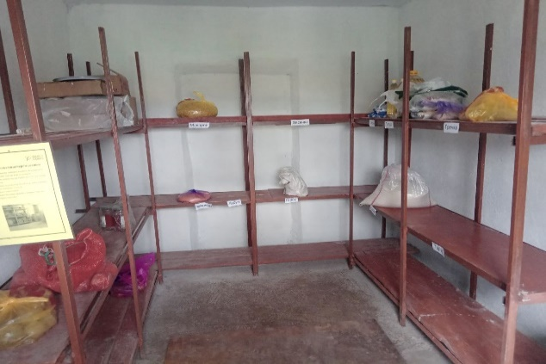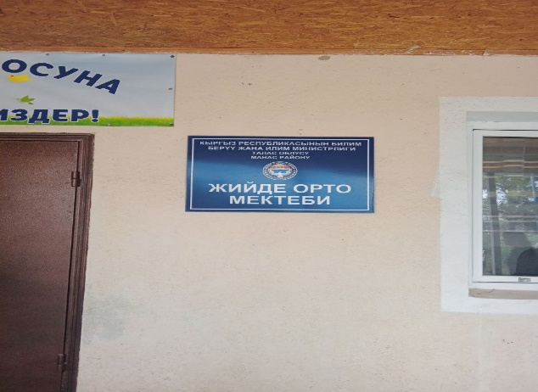
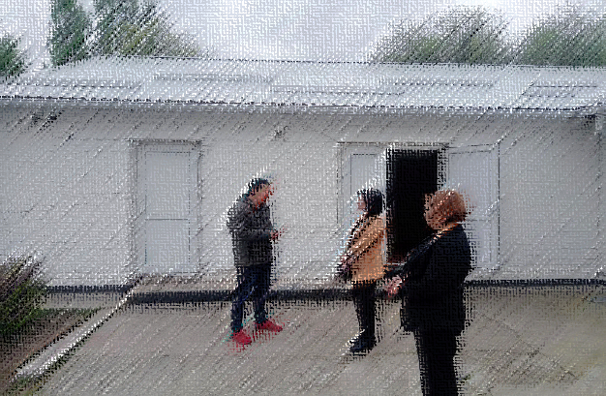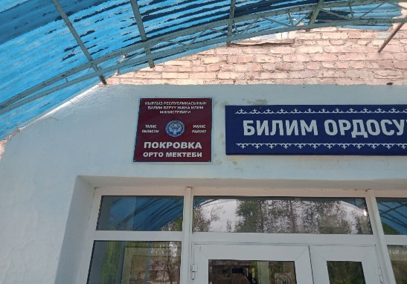
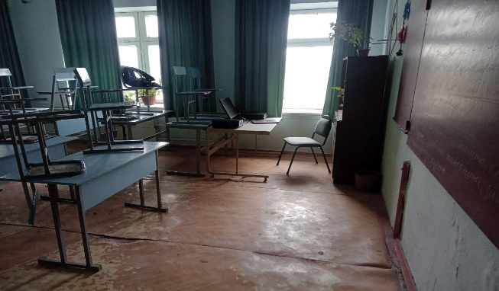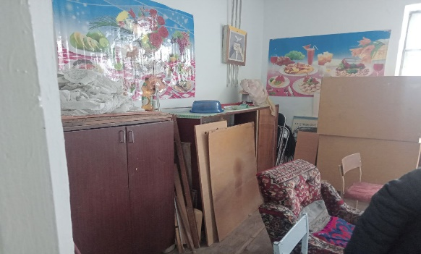
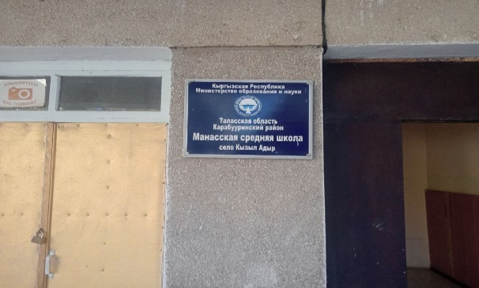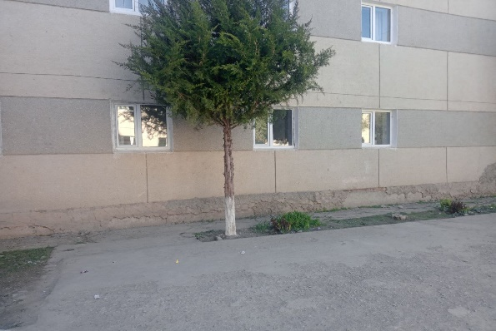

Kara-Buura region:
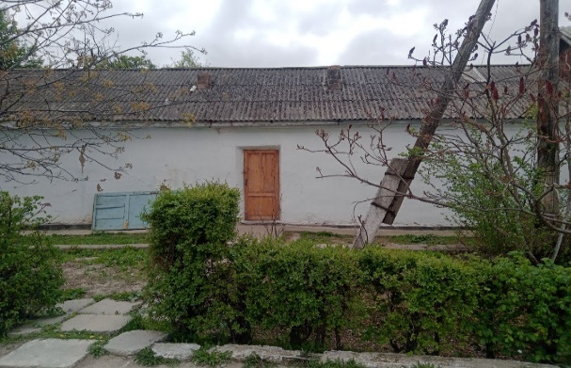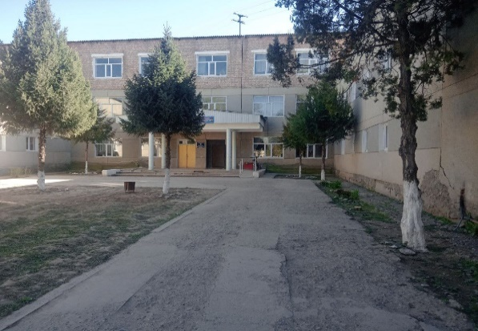
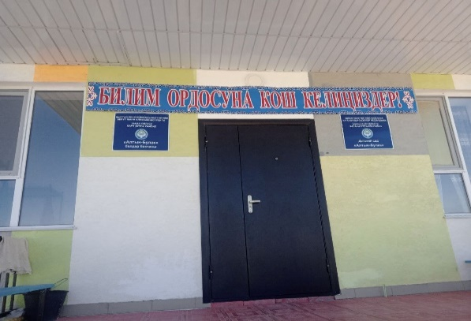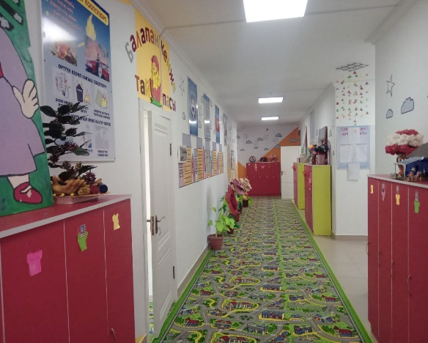
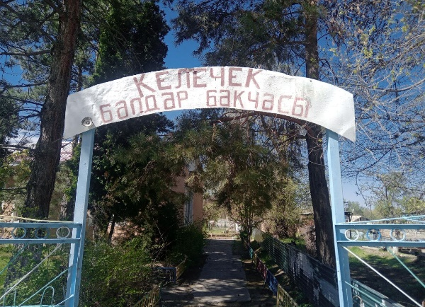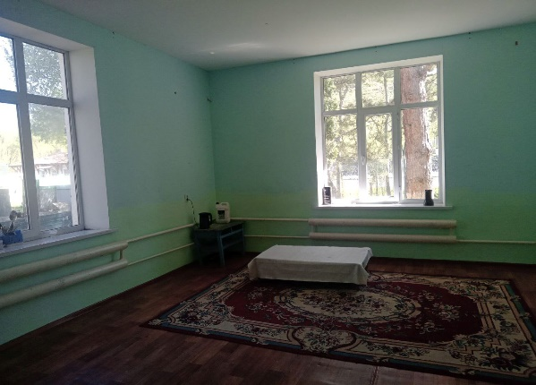
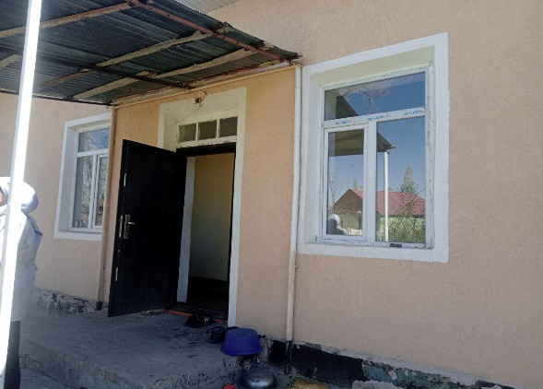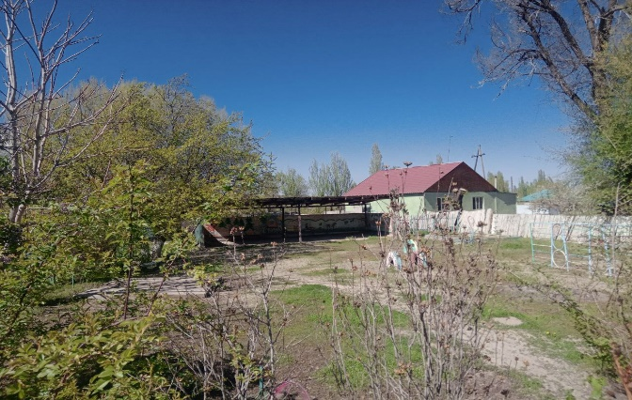
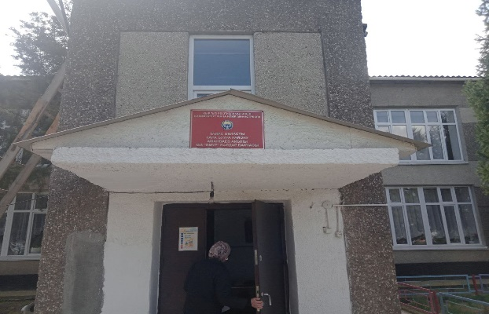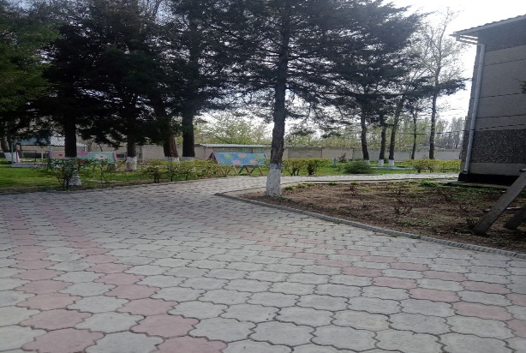
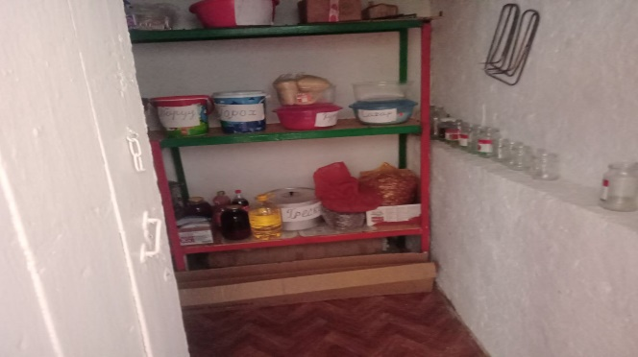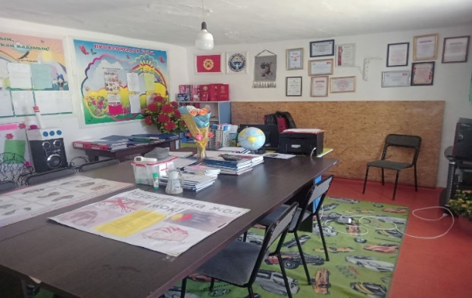
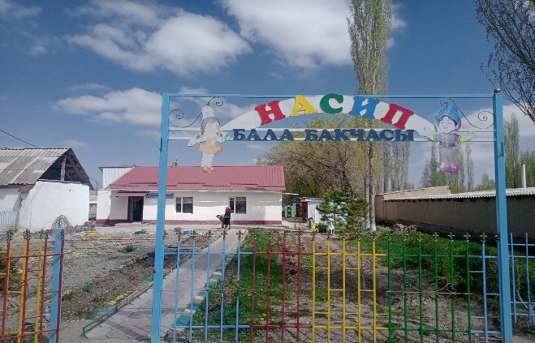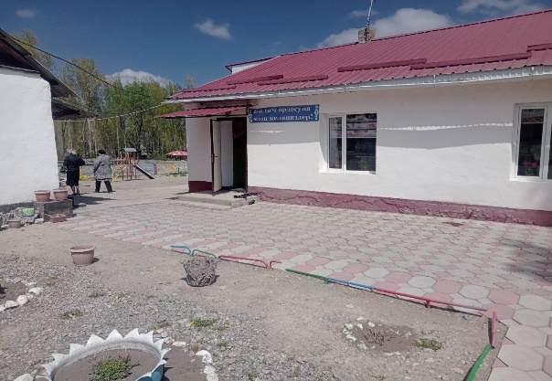
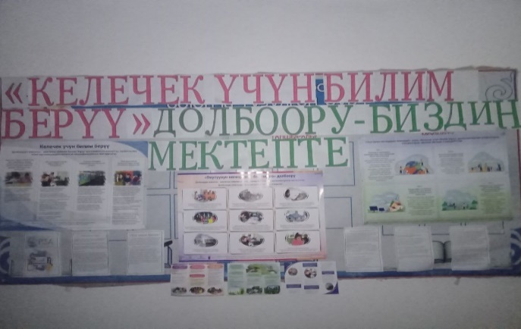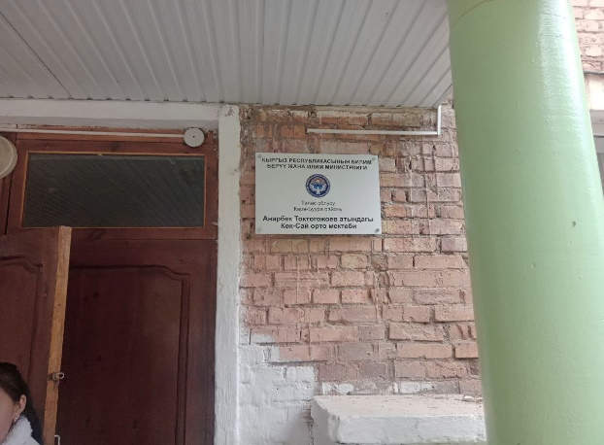
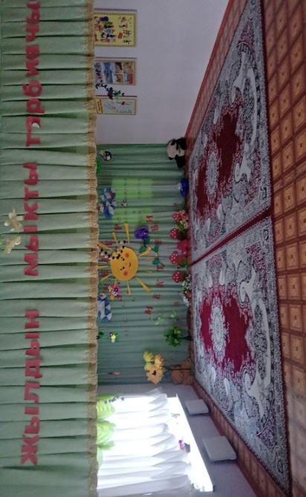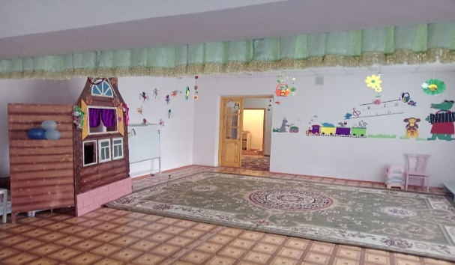
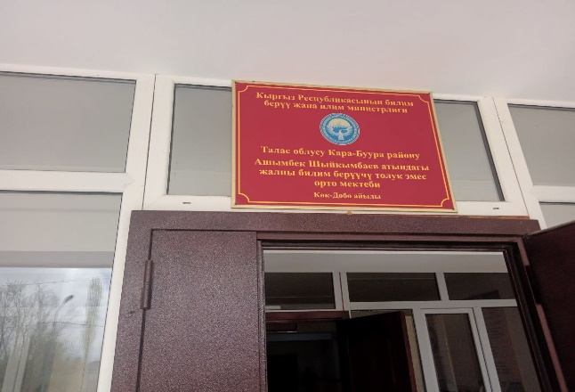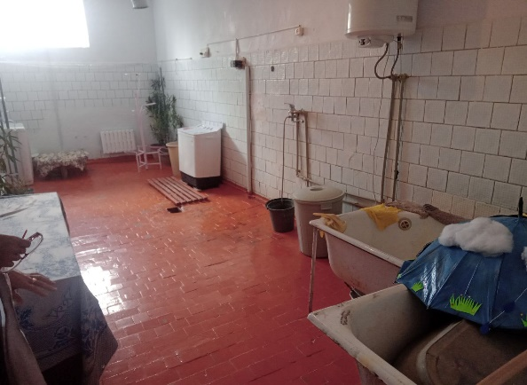

Picture 2. Facility screening in Chui oblast
Yssyk-Ata region:
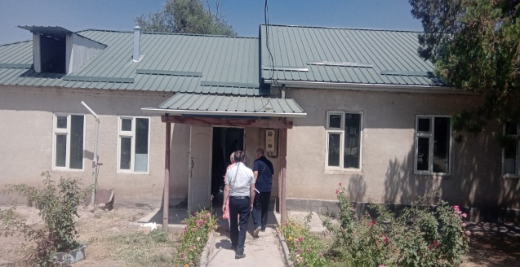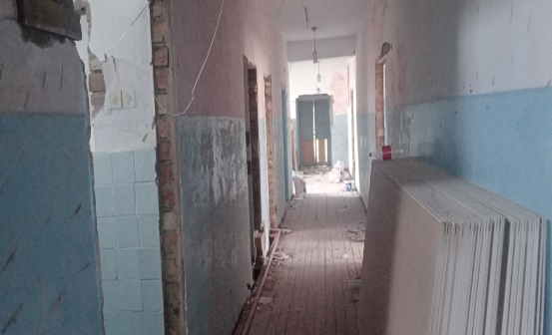
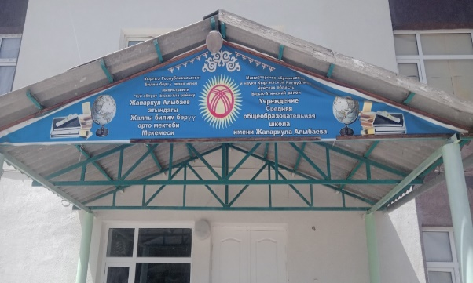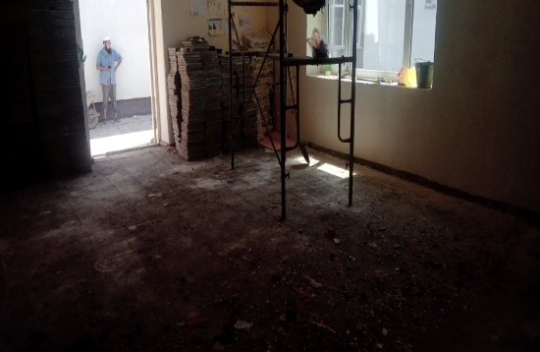
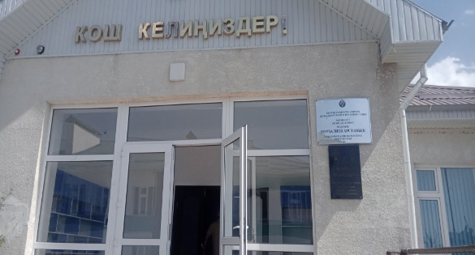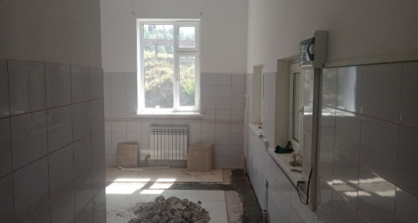
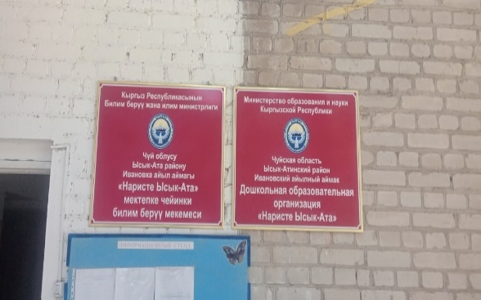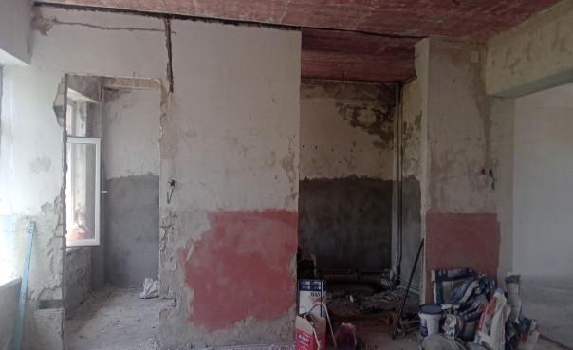
Alamedin region:
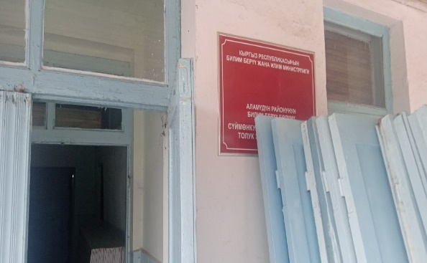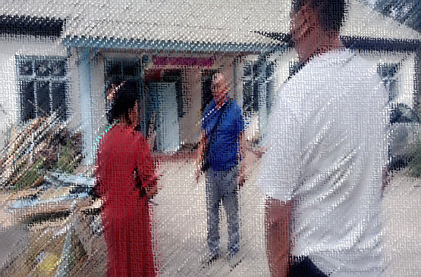
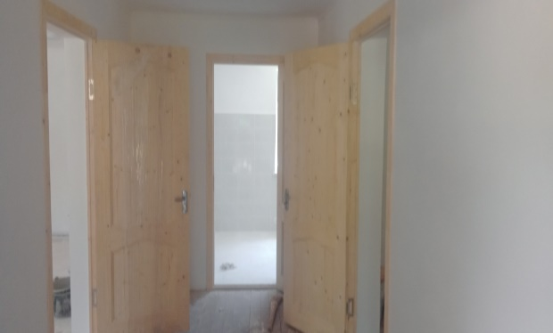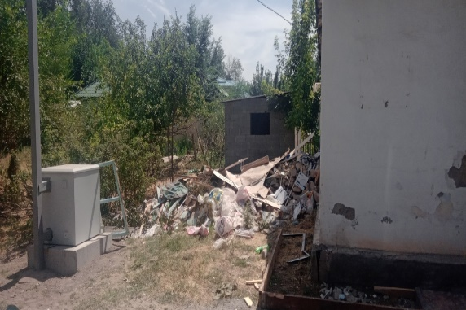
Panfilov region:
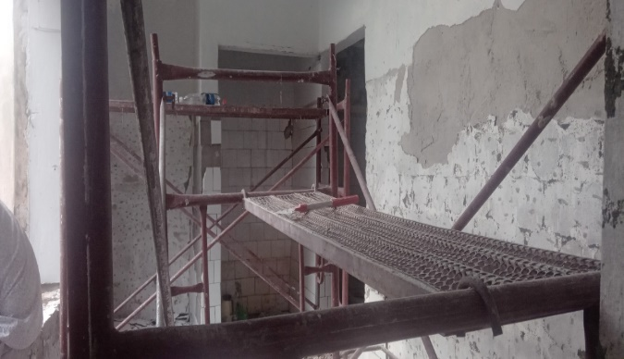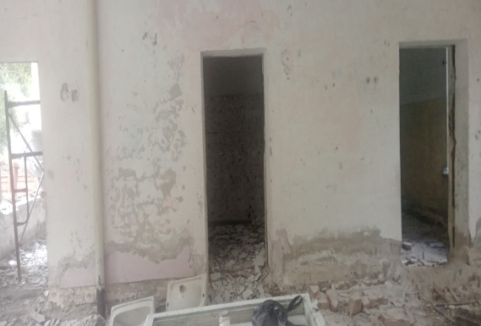
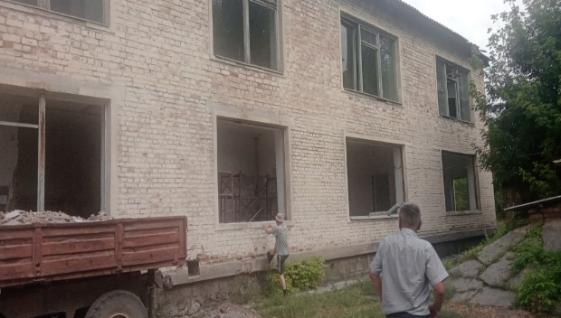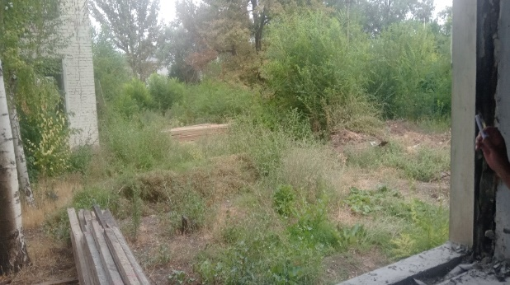

Picture 3. Registered appeals as part of the GM
Picture 4. Awareness raising campaign and meetings with the heads of REDs, Chui oblast
Picture 5. Awareness raising campaign and meetings with the heads of REDs and stakeholders, Talas oblast
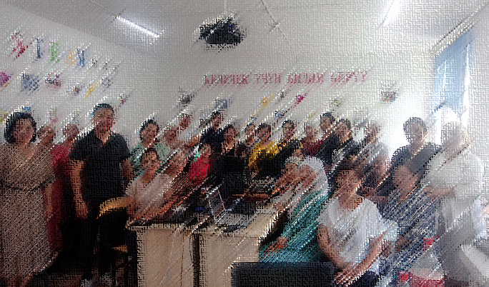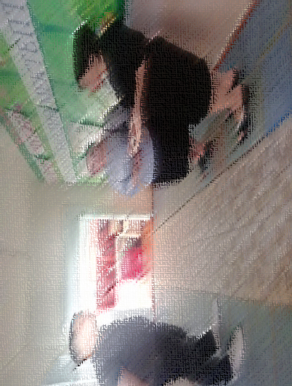
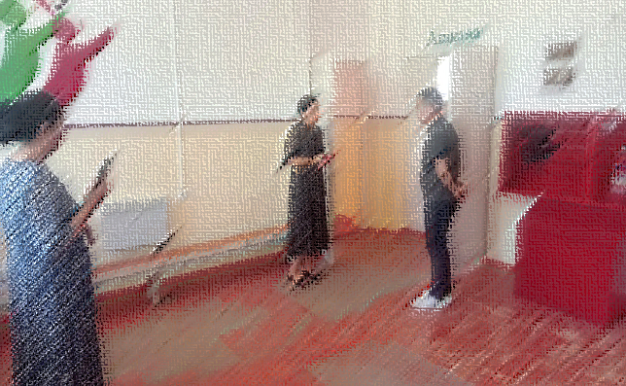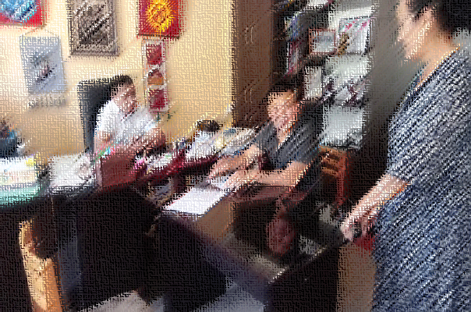
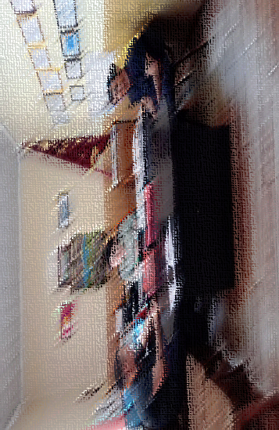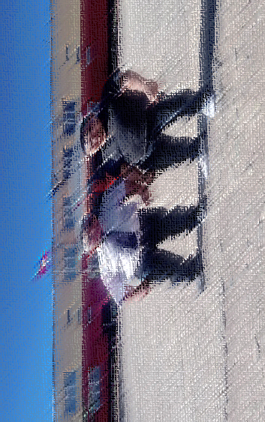
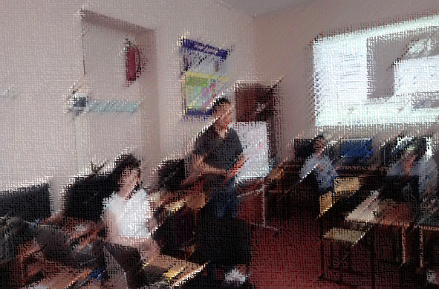
Table 3. Training Plan on social-environmental standards for 2022-2023
Table. Training Plan on social-environmental standards for 2023
№ | Activity | PERIOD | Note
1 | Delivering training for PIU/PCU team, contractor employees, and contractors on the following topics:  - Public Health and Safety Risk Reduction Measures;  - Covid-19 prevention and control recommendations;  - Incident reporting and understanding of Environmental and Social Incident Reporting (ESRI) provisions. | Quarter 2-3, 2023 | Deliver trainings after project staff has been hired and before project activities begin, thereafter in accordance with the project's annual training plans.
2 | Delivering training for PIU/PCU team in:  - WB Social and Environmental Frameworks and Standards;  - Health and Safety Requirements;  - Labor Management Procedures. | Quarter 2-3, 2023 | Deliver trainings after project staff has been hired and before project activities begin, thereafter in accordance with the project's annual training plans.
3 | Delivering training for contracting companies on rehabilitation and restoration work.  (During construction, note the need to take into account the accessibility of infrastructure for people with disabilities (installation of ramp, call button, etc.). | Quarter 2-3, 2023 | After contract with a contracting company is signed.
4 | Insight of contractors into:  - Code of Conduct and SEA/SH risks preventing measures;  - Grievance mechanism for project team and contractors. | Quarter 2-3, 2023 | After contract with a contracting company is signed.

https://edu.gov.kg/organizations/43/pages/206/
Order of the Ministry of Education and Science of the Kyrgyz Republic #1980/1 of 19.11.2021 "On approval of the Regulation on criteria for selection of 60 short-term (3-hour) stay preschool education centers in the Kyrgyz Republic"
See the Operational Manual of the Enhancing the Foundation of Learning project. Paragraph III / Mechanisms of project implementation, page 15
https://edu.gov.kg/organizations/43/posts/602/
https://edu.gov.kg/organizations/43/posts/657/
See Quarterly report of Enhancing the Foundation of Learning Project Q1-3 of 2022 and Q1,2 of 2023.
https://edu.gov.kg/organizations/43/pages/252/
https://edu.gov.kg/legislations/?kind=&direction=&organization=43&number=&title=&content=
https://edu.gov.kg/organizations/43/pages/206/
World Bank Project Implementation/Coordination Unit Order No.01/87 of 22.11.2022 “On approving PIU/PCU Code of Conduct and Ethics”.
https://edu.gov.kg/legislations/?kind=&direction=&organization=43&number=&title=&content=
https://edu.gov.kg/organizations/43/pages/236/
https://edu.gov.kg/organizations/43/posts/1386/ и https://fb.watch/mgaUJY99pH/?mibextid=Nif5oz
https://edu.gov.kg/organizations/43/posts/1880/
In accordance with the privacy policy, photos with people and personal information are hidden in this report

