THE KYRGYZ REPUBLIC

Ministry of Education and Science

Quarterly report
Enhancing the Foundation of Learning Project

Quarter 1, 2023

May-2023

INTRODUCTION

1. Background
In 2018, the President of the Republic approved the ‘National Development Strategy for 2018-2040 (Strategy 2040). Its focus is to create opportunities for human capital development including through education and the creation of highly-productive quality jobs, particularly in strategic sectors. It is fully aligned with the Sustainable Development Goals (SDGs). The first phase of the Strategy 2040, the ‘Development Program of the KR 2018-22 (Program 22)’ acknowledges that the education system is not yet effective in developing the higher order skills that are needed; and identifies several education sector priorities, including: (i) improving the quality of education; (ii) making the education system more effective in teaching skills required by the modern economy; (iii) supplying schools with a broader range of modern teaching-learning materials and innovative technology and (iv) strengthening the professional capacities of teachers. In the latest development, the MoES’s draft of the National Education Sector Strategy 2030 addresses on the following priorities: (i) expanding access to ECE and improving its quality; (ii) strengthening teacher professional capacities to effectively teach skills, including transversal competencies (such as digital literacy) and providing flexible, accessible and affordable continuous professional development; (iii) improving the availability and use of digital teaching-learning materials at schools; and (iv) strengthening assessment systems to ensure children are formatively assessed, summative assessments are aligned with curricular competencies, and sample-based learning outcome evaluations are carried out to identify and remedy system weaknesses.
This report describes the social and environmental activities of the project from October to December 2022.
Environmental and social issues include activities undertaken to manage and minimize adverse environmental and social impacts during implementation of sub-projects of the Enhancing the Foundation of Learning project. In accordance with the environmental and social standards of the World Bank, the procedures and mechanisms necessary for the implementation of appropriate project activities to the standards of the WB, as well as the legal and regulatory acts of the Kyrgyz Republic are covered.
Basis and date of entry into force of the Enhancing the Foundation of Learning Project – The Kyrgyz Republic and the International Development Association signed the Loan Agreement for the Enhancing the Foundation of Learning Project dated July 13, 2021, this Agreement was ratified by the Zhogorku Kenesh of the Kyrgyz Republic on July 29, 2021.
1.1. Project Description
The project objective is to increase equitable access to pre-school education, and to establish conditions for improving its quality. The pre-school institution and its enabling environment are at the core of the project. The project will use a multi-pronged approach that includes three components and several sub-components, as described below.
The pre-school institution and its enabling environment are at the core of The Project. It has two complementary components, as well as an implementation support component.
The first component focuses on enhancing access to quality pre-school education, targeting the poor and vulnerable including minority ethnic groups and children with special education needs. The second component focuses on improving policy, programs and system effectiveness. Successful implementation of these two components would eventually contribute to improved learning outcomes of basic schooling for all.
The third component finances advocacy and communication efforts, monitoring and evaluation and the operating cost to support implementation.

The project consists of 3 components and 5 sub-components.

Component 1: Expanding preschool education for under-served children. The aim of this component is to increase equitable access to early education services that meet quality standards for under-served children in targeted communities.
Sub-component 1.1: Expanded preschool education. The objective of this sub-component is to increase equitable access to quality ECE in poor rural areas with no or low access through establishing CbKs and enhance the effectiveness of teaching-learning practices in preschool.
Sub-component 1.2: Increased effectiveness in teaching practice. The objective of this subcomponent is to increase teacher capacities in preschool education through the strengthened design and delivery of teacher training programs aligned to the recently approved child development standards and evidence from the science of learning.

Component 2: Improving policy & finance for the system effectiveness. The objective of this component is to improve policy and system effectiveness.

Component 3: Ensuring citizens’ engagement and implementation support.
The objective of this component is to ensure that all stakeholders are engaged in project implementation and monitoring.
Sub-component 3.1: Stakeholders’ engagement. Stakeholders will be engaged in the implementation of activities across the project, building on the mechanisms already in place to involve parents, particularly fathers, and community members. Specifically, this includes: (a) the provision of information for parents on importance of early development of children, story books reading through leaflets, posters, guidance on story books reading importance and techniques, etc.; and (b) community monitoring through community scorecards.
Sub-component 3.2: Evaluation. To assess the project impact, an evaluation using Randomized Control Trials (RCT) will be conducted to determine if participation in the project supported CbKs had an impact on child development.
Sub-component 3.3: Implementation support. This component will support the coordination, technical quality and fiduciary integrity, compliance with environmental and social standards in due course of implementation, as well as the monitoring, evaluation and reporting on project processes and results. It will also support systems for collecting beneficiary feedback to inform project implementation.
2. MONITORING AND REPORTING

The Enhancing the Foundation of Learning project focuses on monitoring and reporting according to approved project implementation plans, compliance with socio-environmental standards, stakeholder engagement plan, labor management procedures, socio-environmental commitment plan, environmental and social management plan, grievance mechanisms, and sexual exploitation and abuse/sexual harassment.
During the reporting period, no incidents or accidents within the framework of the Enhancing the Foundation of Learning project were reported.

3. LEGAL AND REGULATORY ACTS ADOPTED AS PART OF THE IMPLEMENTATION OF THE ENHANCING THE FOUNDATION OF LEARNING PROJECT
3.1. In order to achieve the goals and objectives of the Enhancing the Foundation of Learning project, the following legal and regulatory documentation was prepared and adopted:
- Order of the Ministry of Education and Science of the Kyrgyz Republic #1980/1 of 19.11.2021 "On approval of the Regulation on criteria for selection of 60 short-term (3-hour) stay preschool education centers in the Kyrgyz Republic";
- Order of the Ministry of Education and Science of the Kyrgyz Republic #397/1 of 18.03.2022 "On formation of the permanent commission on selection of community-based kindergartens/preschool education centers";
- Order of the Ministry of Education and Science of the Kyrgyz Republic #398 of 18.03.2022 "On introducing amendments to the Regulation on criteria for selection of 60 short-term (3-hour) stay preschool education centers in the Kyrgyz Republic";
- Order of the Ministry of Education and Science of the Kyrgyz Republic #1429/1 of 14.07.2022 "On approval of the preliminary list of newly selected buildings for establishment of 60 community-based kindergartens/preschool education centers";
- Order of the Ministry of Education and Science of the Kyrgyz Republic #1303/1/1/1 of 01.07.2022 "On accounting of inventories" including quality control of inventories to ensure the safety of children;
- Grievance mechanism for Projects Coordination Unit (PCU) staff and contract specialists approved by the Deputy Minister of Education and Science of KR;
- Order of the World Bank Projects Implementation/Coordination Unit #01/87 of 22.11.2022 "On Approval of the Code of Business Conduct and Ethics of PIU/PCU".

3.2. Incident and accident notification
- At this time during the implementation of the project, rehabilitation and construction work on the facilities has not yet started. Tenders have now been issued for the establishment of 60 community-based kindergartens/preschool education centers.

4. ESS 1: ENVIRONMENTAL AND SOCIAL RISK AND IMPACT ASSESSMENT AND PREVENTION:
To ensure the implementation of the project in accordance with the Environmental and Social Commitment Plan, socio-environmental standards and other environmental and social instruments, a number of activities were carried out during the reporting period.
4.1. Organizational structure
- As part of the implementation of the Enhancing the Foundation of Learning project, the PIU/PCU coordinator, social specialist, environmental specialist, and engineer under the Ministry of Education and Science of the Kyrgyz Republic are working jointly.
  - Selection mechanisms
According to the criteria for selecting buildings for the establishment of 60 (CbKs), priority areas (cities/towns) for selection and participation in the project are:
- areas (small towns) with low income;
- areas (small towns) with a low level of enrollment of children in preschool education;
- border, high-mountain and remote areas (small towns) with low incomes and coverage of children with preschool education;
- areas (small towns) inhabited by ethnic minorities, internal and external migrants.
Children with disabilities, children from poor households with limited educational opportunities, children of migrants and disadvantaged populations, children with physical disabilities will be included in the categories of children to be taught in the CbKs.
4.3. Transparent procedures and processes for selecting communities to engage in the project have been developed and implemented:
- Premises (based on schools, kindergartens, village first-aid stations (FAPs), clubs, offices, etc.);
- Documents of title for the provided building (technical passport, document of title);
- Letter of guarantee from aiyl okmotu addressed to the Minister stating that the provided premises will be used for 10 years;
- Letter from the regional state administration addressed to the Minister stating that they support this project and agree to participate in this project;
- Letter of guarantee from the regional educational departments stating that the salaries of future teachers will be included in the republican budget;
- Number of out-of-school children from 3 to 7 (waiting in line);
- Consent of the sanitary and epidemiological station (to the opening a kindergarten in provided premise/building);
- Consent of the Ministry of Emergency Situations (documentary evidence);
- Photos of the premises.

In total, out of 90 applications throughout the country, 60 CbKs were selected according to the above criteria(Table 1):
During this period the tender applications are being evaluated and the final list of all 60 facilities is being finalized.

4.4. Principles of environmental and social management
In Q1 2023, screening was conducted (Table 2) at facilities in Osh (12 facilities) and Batken oblasts (4 facilities). Total percentage of screenings conducted is 78.3% (Pictures 1,2).
In 2-3 quarters of 2023 it is planned to complete facility screenings. In 2023, field visits and screening at approved CbK facilities are planned for the remaining oblasts of Kyrgyzstan (Chui oblast).

4.5. Environmental and social screening and ESMP
During the reporting year, 1 face-to-face and 3 online (via phone and Whatsapp messenger) consultations of heads and staff of educational departments in Jalal-Abad, Batken, Talas oblasts were conducted regarding the application of environmental and social standards in the process of designing facilities (construction and placement of septic tanks, rehabilitation and construction works, etc.).
In the framework of the Enhancing the Foundation of Learning project the preparation and approval of ESMPs is being done.

5. ESS 2: HUMAN RESOURCES AND WORKING CONDITIONS
The Enhancing the Foundation of Learning project is implemented in accordance with regulations and, in particular, labor management procedures adopted and approved by the World Bank, in order to meet socio-environmental standards.
5.1. Human resources management procedure
The Code of Conduct and Ethics of the WB Project Implementation and Coordination Unit of the Ministry of Education and Science of the Kyrgyz Republic was signed by:
- 21 staff members of the Enhancing the Foundation of Learning project PIU/PCU and included in the employment contract, as an appendix.
- The Code of Conduct and Ethics was distributed to the Enhancing the Foundation of Learning project coordinators to be signed by 32 contracted professionals and companies.

5.2. Project staff training
According to the implementation of environmental and social commitment plan, information, implementation of the project and in order to conduct trainings for PIU/PCU key staff members, contract specialists and contractors the collection of information materials to do a presentation and videos on social issues (information on safety, health, health safety, prevention of gender-based violence and discrimination, first aid, labor relations, COVID 19) was completed.
During the reporting period it was prepared:
- 1 animated video on COVID-19 disease prevention;
- 1 presentation on grievance mechanism.

6. GRIEVANCE MECHANISM
6.1. Grievance mechanism
The project applies a system to ensure feedback from the project beneficiaries, citizens of the Kyrgyz Republic, the public and dissemination of all information related to the project, the proper consideration of complaints and responses and their reporting.
Staff of WB PIU/PCU, contract specialists, employees of regional education departments, local authorities, directors of schools and community-based kindergartens under the Learning for Future and Enhancing the Foundation of Learning projects are informed about the grievance mechanisms (GMs) and also about protection against retaliation or abuse of power by the employer.
Abovementioned employees have the opportunity to file a complaint or suggestion about the progress of construction, environmental and social protection activities, complaints and concerns related to COVID-19, sexual exploitation and abuse (SEA)/sexual harassment (SH), gender-based violence through the following channels:
- Oral and written referrals during meetings between PIU/PCU staff and stakeholders;
- By telephone: + 996 312 31 70 16;
- Through Whatsapp: +996 777 555 882;
- By fax: +996 312 31 70 16;
- By e-mail: officeorp@gmail.com;
- Project sub-site: www.edu.gov.kg/organizations/43/posts;
- Postal correspondence: Bishkek, Manas Ave. 22 A
6.1.1. Grievance Mechanism for key staff of PIU/PCU and Grievance Mechanism were developed in accordance with the stakeholders, approved by the Deputy Minister of Education and Science of the Kyrgyz Republic, posted on the website of the MES KR.
6.1.2. An electronic logbook of GM has been prepared and kept to record incoming grievances.
During the reporting period 2 proposals were received. In this period of the project implementation, the referrals are mainly of advisory and informational nature related to the ESMP and commencement of construction of CbKs (picture 3).
6.1.3. The GMs have been presented to the CbK coordinating staff of Regional Educational Departments and a request has been made to place the GMs in the buildings of Regional Educational Departments, Aiyl Okmotu, schools, kindergartens (as part of the implementation of the SEP under the World Bank projects) in:
- Osh oblast (Osh city, Uzgen city, Alay, Chon Alay, Aravan, Kara-Kulja, Kara-Suu, Uzgen rayons);
- Batken oblast (Batken city, Razzakov, Batken, Kadamjai, Leilek rayons).

6.1.4 According to the Stakeholder Engagement Plan during the meetings with representatives of Aiyl Okmotu, heads and staff of regional educational departments, school and kindergarten directors, socially vulnerable population 3 consultations on GM issues were provided (Batken oblast - 2, Osh oblast - 2).

6.2. SEA/SH risk mitigation:
In order to mitigate the risks of sexual exploitation and abuse/sexual harassment, awareness-raising activities have been carried out among WB PIU/PCU and contracted professionals.
During the reporting period, the Code of Conduct and Ethics of the World Bank Project Implementation and Coordination Unit under the Ministry of Education and Science of the Kyrgyz Republic was drafted and approved by PIU/PCU order.
The Code is signed by all Enhancing the Foundation of Learning project staff and thereafter the signed document was included in the employment contract of employees. The Code reflects the norms of behavior of employees in everyday life, at work and obligations to avoid sexual exploitation and abuse, as well as sexual harassment.
No violations of the Code of Conduct and Ethics and no complaints have been registered to date.
WB’s PIU/PCU staff (Erkinbekov, Zhumaliev, Dzhamansariev) participated in a training on gender commitments organized by the World Bank staff (14.04.2023).

7. ESS 10: STAKEHOLDER ENGAGEMENT AND INFORMATION DISCLOSURES

The overall objective of this Stakeholder Engagement Plan (SEP) is to define a program of stakeholder engagement, including public information and consultation, during the preparation and implementation of the proposed project. The SEP outlines ways to identify potential different stakeholders, develop an approach to reach each sub-group, establish a mechanism through which Project Affected Parties (PAPs) and other stakeholders can report concerns, provide feedback or complaints, and minimize and mitigate environmental and social risks associated with the proposed project.
Overall, the SEP serves the following objectives: (i) identification and analysis of stakeholders; (ii) planning of engagement forms, effective communication tools for consultation and disclosure; (iii) provision of platforms to influence decisions; (iv) identification of roles and responsibilities of various actors in implementing the Plan; and (iv) grievance mechanism (GM).
The Stakeholder Engagement Plan was adopted and endorsed by the World Bank and published on the MES website.
Based on the requirements of the SEP and during the reporting period, the following activities were carried out:

7.1. Prepare and implement a stakeholder engagement plan.
As part of the implementation of the Enhancing the Foundation of Learning project, the preparation is taking place with the involvement of various project stakeholders, starting with the conceptual stage of the project. The following types of stakeholder engagement activities have currently been implemented:
- Regular consultations and joint work with heads and responsible employees of regional and city education departments (46 rayons of the country) to provide information on stages of construction of CbKs, operative information exchange with MES KR and provision of advice on distribution of tripartite contracts of the project (60 CbKs) (picture 4);
- Based on the revision documents, opinions of the Ministry of Emergency Situations of the Kyrgyz Republic on the accident rate of some facilities, the decision of Ayil Okmotu to build full-fledged kindergartens (instead of short-term CbKs), refusal of Ayil Okmotu and bidding procedures, some facilities are now being replaced;
- Awareness-raising activity was conducted and a series of meetings with stakeholders (deputy Akims on social issues, heads of executive bodies of local governments, heads and staff of regional and city education departments, school principals, directors and teachers of CbKs) was organized in Osh (5 rayons and 1 city), Batken (3 rayons and 4 cities/towns), regions (sub-component 1.1. of the Enhancing the Foundation of Learning project);
- during the meetings a presentation was made on sub-components of the Enhancing the Foundation of Learning and Learning for the Future projects, the information about the main objectives, scheduled activities, preparatory work, timelines and implementation mechanisms was announced;
During the meetings the information was provided:
- about World Bank project standards for introduction and implementation of grievance mechanisms and socio-environmental standards, bringing this information to the heads of executive bodies of local self-government, employees of REDs, school and CbK directors and local community (picture in 6);
- on providing tripartite agreements for establishment of CbKs under sub-component 1.1 of the Learning for the Future (500 CbKs) and Enhancing the Foundation of Learning (60 CbKs) projects and on providing the lists of teachers of these projects;
- on a zoom-meeting held with the heads of REDs on the implementation of the Enhancing the Foundation of Learning project (link: https://edu.gov.kg/organizations/43/posts/896/), MoES Order No.1303/1 of 01.07.2022 "On inventory control", Order No.1682/1 of 02.09.2022 "On preparation of electronic library and acceptance of inventory;
- on the fulfillment of obligations under the tripartite agreements between the Ministry of Education and Science of the Kyrgyz Republic, the heads of executive bodies of local self-government, school principals on behalf of the regional education department;
- on the need to pay attention to the quality of accepted furniture, supplied products, methodological publications, sports grounds, and on the formation of commissions for admission;
- on the protection of the children and staff health.
- during the meeting, explanatory and awareness-raising event were held with the staff of Aiyl Okmotu, REDs, principals, kindergarten teachers and teachers. Information was provided on grievance mechanisms (GMs), Learning for the Future, Enhancing the Foundation of Learning projects. A request was made to distribute and post GMs and information materials on information boards in Aiyl Okmotus, REDs, schools and kindergartens to inform the local population (picture 7);
- Zhumaliev, environmental specialist, conducted public consultations and provided information on implementation of the ESMP in Batken oblast under the Learning for the Future project. During public consultations it was noted that each subproject of the ESMP ensures identification, minimization and mitigation of potentially adverse environmental and social impacts within the implementation of Subcomponent 1.1 (Picture 8);
- The developed ESMPs for Batken Oblast for each subproject, which are available on the MoES KR website, reflect the basic rules and requirements of both Kyrgyz Republic legislation and World Bank socio-environmental standards to avoid potentially adverse environmental and social impacts during implementation of rehabilitation works;
- Consultation was held with the staff of Aiyl Okmotu, REDs, directors, kindergarten teachers and teachers of Osh, Batken oblasts on the posting of the above information in educational institutions.
7.1.1. According to the Stakeholder Engagement Plan, during meetings with the heads of Aiyl Okmotu, heads and staff of education departments, school principals and CbK directors, five consultations were held on the project implementation and construction of CbKs (Talas region – 1, Naryn region – 2, Issyk-Kul region – 2).
7.1.2. Information on the Enhancing the Foundation of Learning project, posters "Social and Environmental Standards", booklets on the Enhancing the Foundation of Learning project and "Social and Environmental Standards", the approved document "Grievance Mechanisms" were provided duringtrips to the regions and information on the need to post them in regional educational departments, Aiyl Okmotu, schools and kindergartens was provided to heads of REDs.
7.1.3. During the reporting period, posters on Enhancing the Foundation of Learning project (1,200 pcs), posters on social and environmental standards (800 pcs), booklets (4,000 pcs), document "Grievance Mechanisms" (620 pcs) were distributed to regional education departments (Picture 9, 10).
The above information was distributed and posted in the educational institutions in:
- Osh oblast (Osh city, Nookat, Uzgen, Kara-Kulja, Aravan, Kara-Suu rayons);
- Batken oblast (Batken city, Kyzyl-Kiya, Razzakov, Kadamjai towns and Batken, Leilek, Kadamjai rayons) (Picture 11).
7.1.4. Selected public consultations have been conducted (in online format) to comply with World Bank (WB) environmental and social standards and national legislation of the Kyrgyz Republic (KR), as well as to inform stakeholders about the ESMP, GM, Code of Business Conduct and Ethics, and the main objectives of the WB funded Learning for the Future (LFF) and Enhancing the Foundation of Learning (EFL) projects under MoES KR (Osh, Batken, Jalal-Abad, Chui, Talas, Yssyk-Kul oblasts);
7.1.5. The outcome of the WB Enhancing the Foundation of Learning and Learning for the Future projects in Osh and Batken oblasts was highlighted in the media and social networks (Picture 12).

Osh oblast:
15 March 2023, the project organized a press tour with media representatives from Kara-Suu rayon of Osh oblast and the city of Osh. During the press tour journalists were provided with information about the Learning for the Future and Enhancing the Foundation of Learning projects, about granted computer and office equipment to 1200 schools and 8 teacher training colleges of the Kyrgyz Republic.
The press tour was attended by a group of correspondents from 8 (eight) Kyrgyz TV channels: NTRC, ElTR, Yntymak ORTRC, OshTV, Osh Pirim, Region TV, Asia TV and T-Media. News items were broadcast on the above-mentioned TV channels whose representatives participated in the press tour.
The attendance sheet and links to the news items are attached:

Links to the news items:
NTRC - https://www.youtube.com/watch?v=OQ8SkhvnJIU
ElTR – https://www.youtube.com/watch?v=v9igaC31SO4
Osh TV – https://www.youtube.com/watch?v=7N877P6iRlI
https://www.youtube.com/watch?v=xbbKkoxtzXI
Osh Pirim – https://www.youtube.com/watch?v=JBusGh0fVoo
Yntymak ORTRC – https://fb.watch/jrFAI-koaL/
Asia TV – https://www.youtube.com/watch?v=cRPO6n0zIqI
Region TV – https://www.youtube.com/watch?v=bzQPwbYhGIg
https://www.youtube.com/watch?v=5lWUSlcNZ0Q
Т-media - https://youtu.be/onz8k2QiAG8
https://fb.watch/jrFGr1-4ff/

Batken oblast:
- https://www.youtube.com/watch?v=wm-cwDcVTm0
- https://www.youtube.com/watch?v=Uu2VA7s2GQI

8. CAPACITY BUILDING (TRAINING)
Capacity building and trainings occupy a special place in the awareness of stakeholders, PIU/PCU staff, contract employees, contractors, due to the need to be informed about the legal and regulatory documents of the Kyrgyz Republic, socio-environmental standards of the World Bank, GM, the Code of Conduct and Ethics and other documents.
Prior to the start of the construction works, it is planned to deliver trainings on SES for PIU/PCU staff and contractors:

9. IT IS SCHEDULED:
Based on the annual plan, the following types of activity are scheduled to be conducted by the WB PIU/PCU staff in the next reporting period in Q2-3-4 of 2023:
9.1 Approval and drafting of the ESMPs for 60 facilities;
9.2 Activity to familiarize contractors with the Code of Conduct and Ethics;
9.3 Organization of trainings for the PIU/PCU staff, contract employees, contractors involved in the implementation of the Project on the topics as per the plan (Table 3).
9.4 Monitoring the commencement of construction of facilities in regions.

Annex to the report:

Table 1. Selected premises for the establishment of CbKs
№ | Rayon | Number of buildings | Number of children
 | Naryn | 3 | 218
 | Kochkor | 2 | 155
 | Ak-Suu | 4 | 230
 | Jeti Oguz | 1 | 100
 | Ton | 0 | 0
 | Yssyk-Ata | 2 | 170
 | Kemin | 2 | 180
 | Moskowsky | 1 | 75
 | Panfilov | 2 | 350
 | Kara-Buura | 9 | 677
 | Manas | 3 | 208
 | Talas city | 0 | 0
 | Toktogul | 0 | 0
 | Bazar-Korgon | 5 | 210
 | Nooken | 2 | 100
 | Suzak | 4 | 210
 | Aksy | 2 | 166
 | Chatkal | 2 | 100
 | Alay | 3 | 150
 | Nookat | 2 | 100
 | Aravan | 5 | 150
 | Kara-Kulja | 2 | 100
 | Batken | 2 | 160
 | Leilek | 2 | 120

Table 2. Screening conducted
No. | Oblast | No. of screenings conducted
1 | Jalal-Abad | 13
2 | Naryn | 3
3 | Talas | 10
4 | Issyk-Kul | 5
5 | Osh | 12
6 | Batken | 4
Total – 47 facilities (78.3% done)

Picture 1. Facility screening in Batken oblast
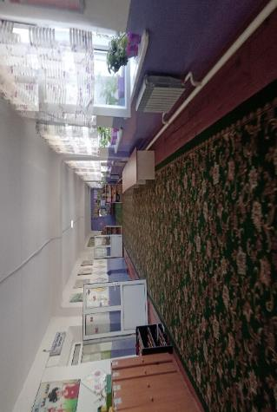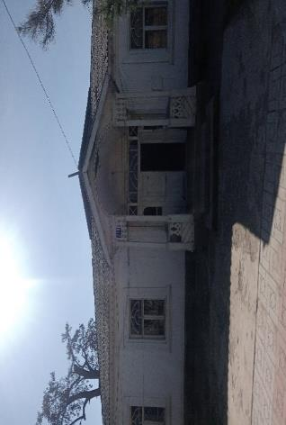
Picture 2. Facility screening in Osh oblast
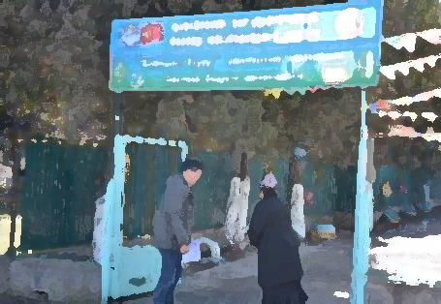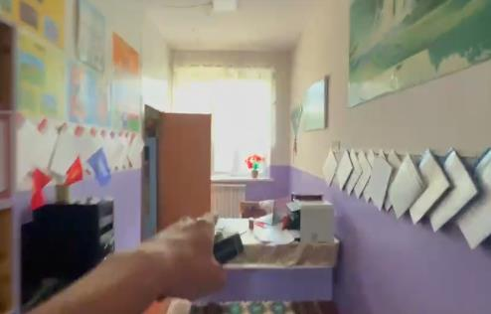

Picture 3. Registered appeals as part of the GM
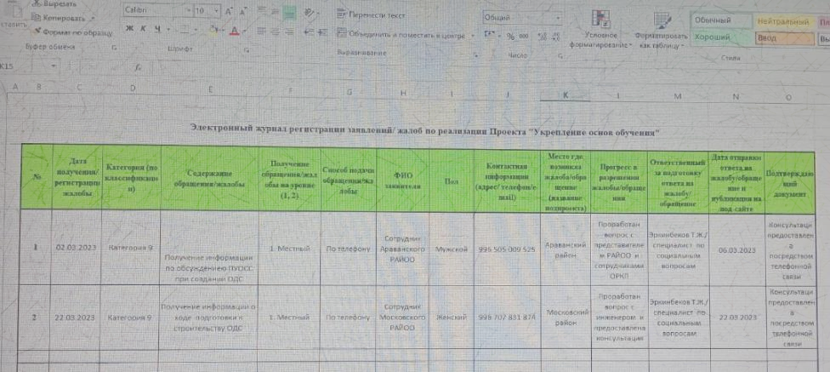

Picture 4. Signed tripartite agreements on the construction of 60 CbKs
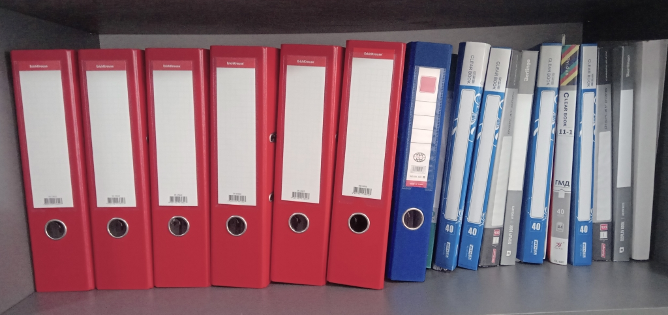

Picture 5. Attendance sheet of the meeting in Leilek rayon, Batken oblast
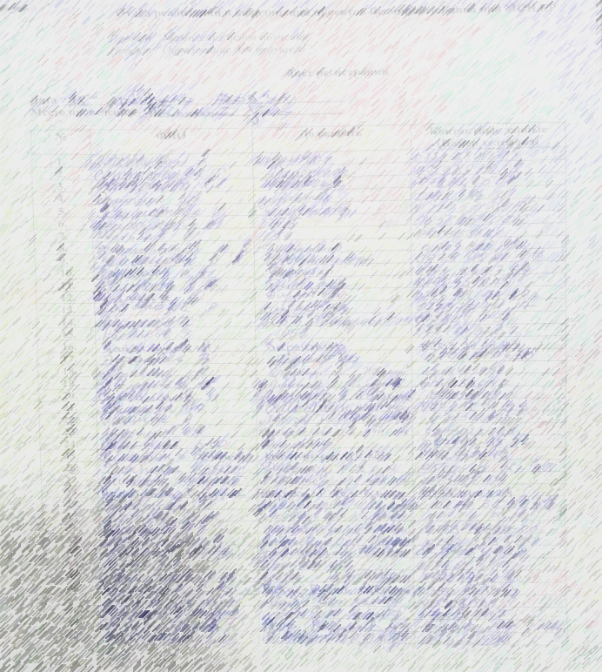

Picture 6. Public awareness-raising campaign during trip to Batken and Osh oblasts
Batken oblast 14-18.02.2023
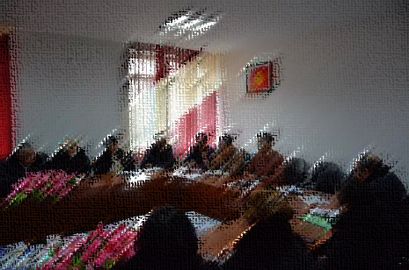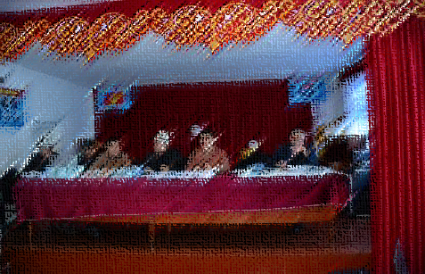
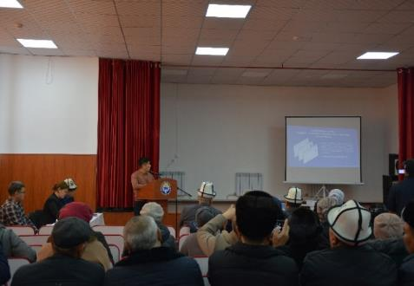
Osh oblast, 12-19.03.2023
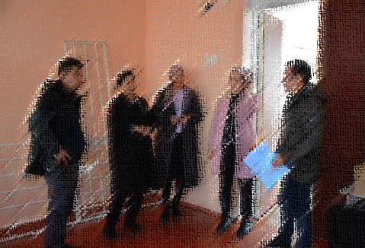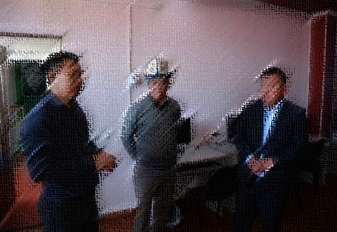

Picture 7. Outreach activity and awareness-raising campaign
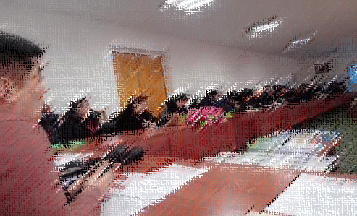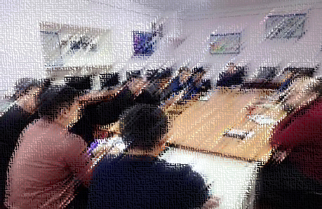
Picture 8. Public consultations and information on EMPS implementation
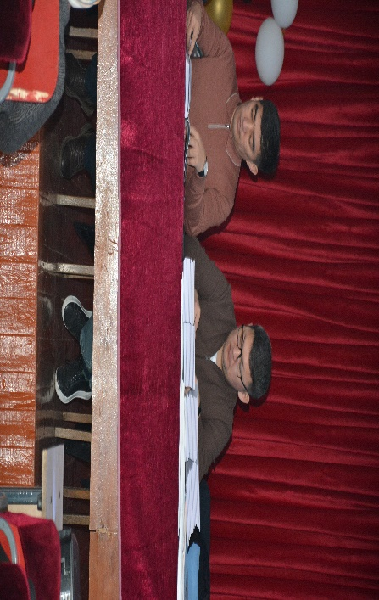
Picture 9. GM and information materials acceptance/transfer act
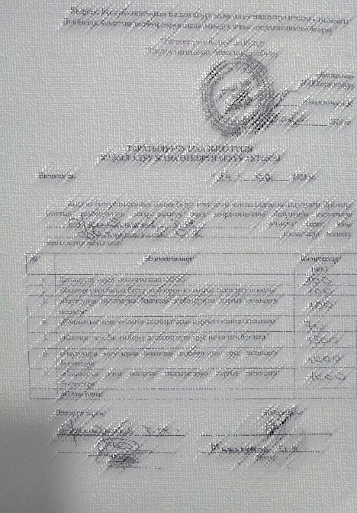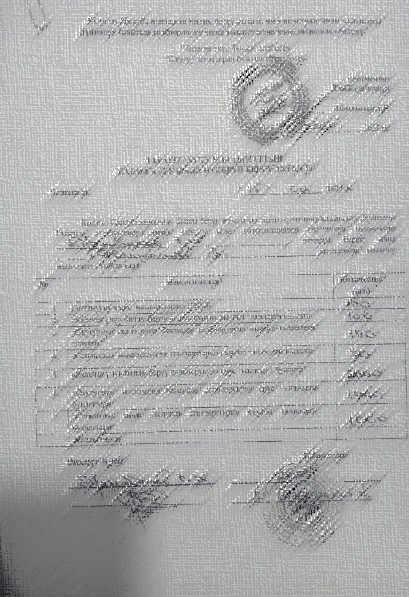

Picture 10. Distribution of information materials during trips to Osh and Batken oblasts
Osh oblast
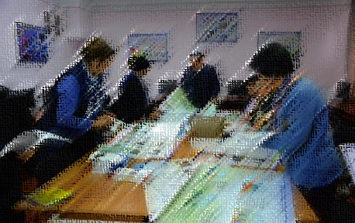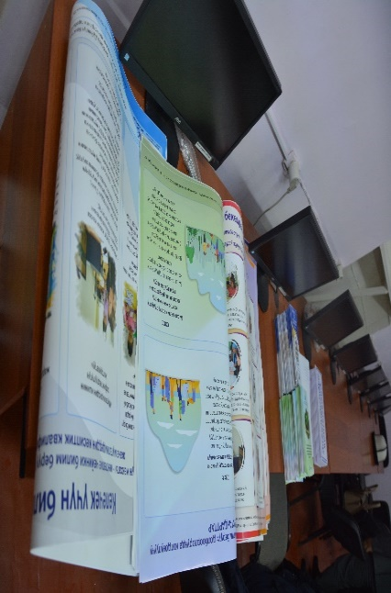
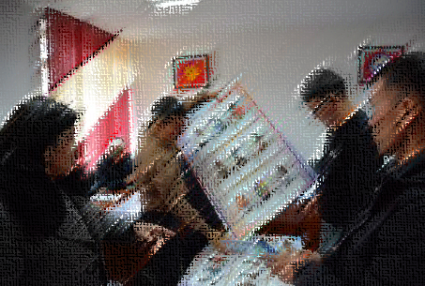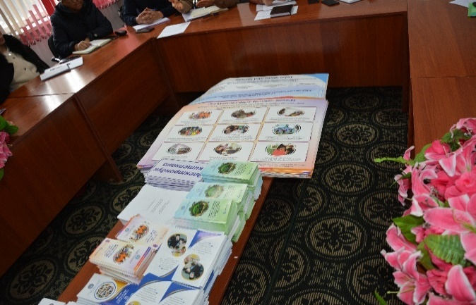
Batken oblast
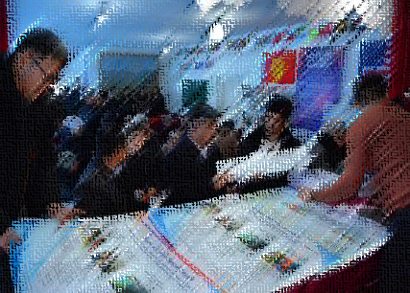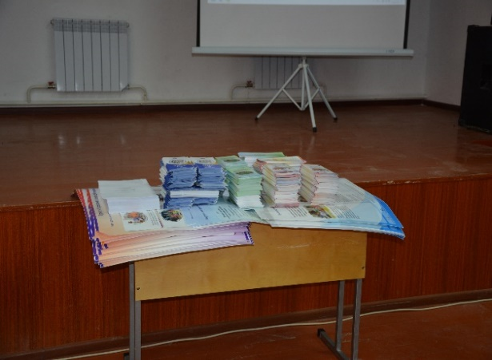

Picture 11. Posting the Enhancing the Foundation of Learning and Learning for the Future Projects posters and GMs in the educational institutions
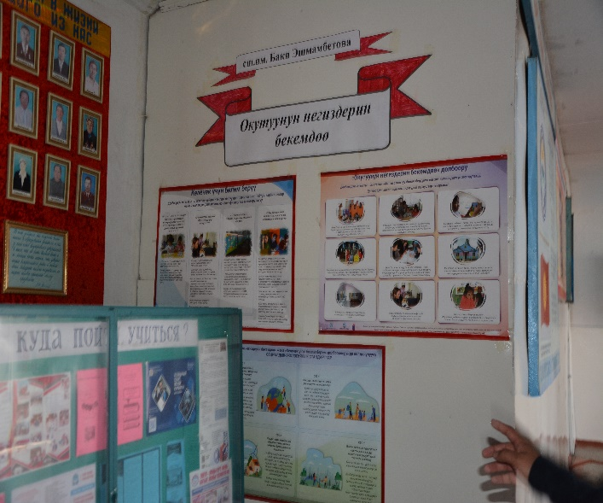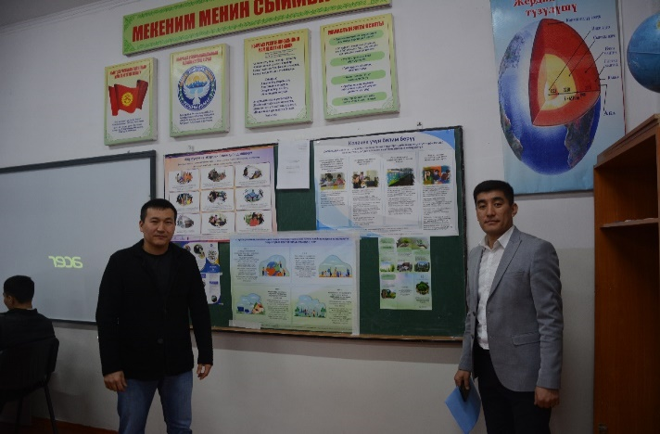
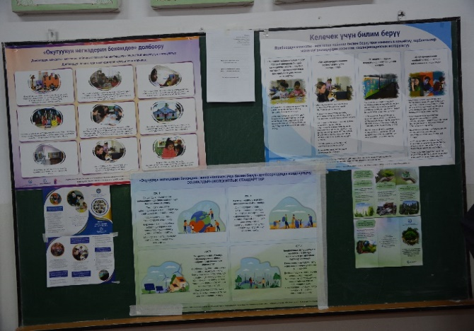
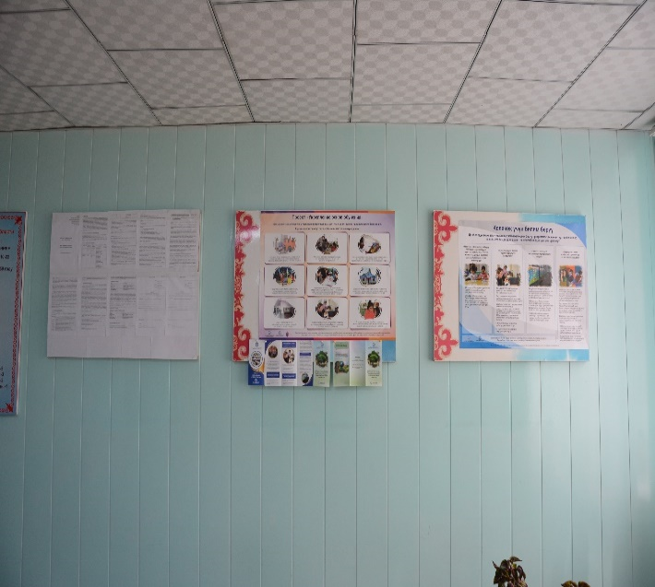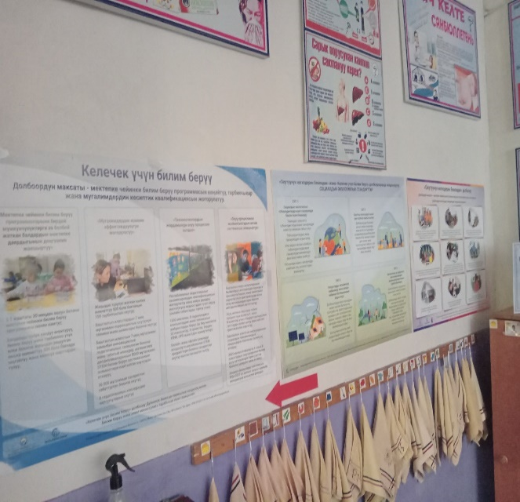
Picture 12. Press tour and media coverage of trips
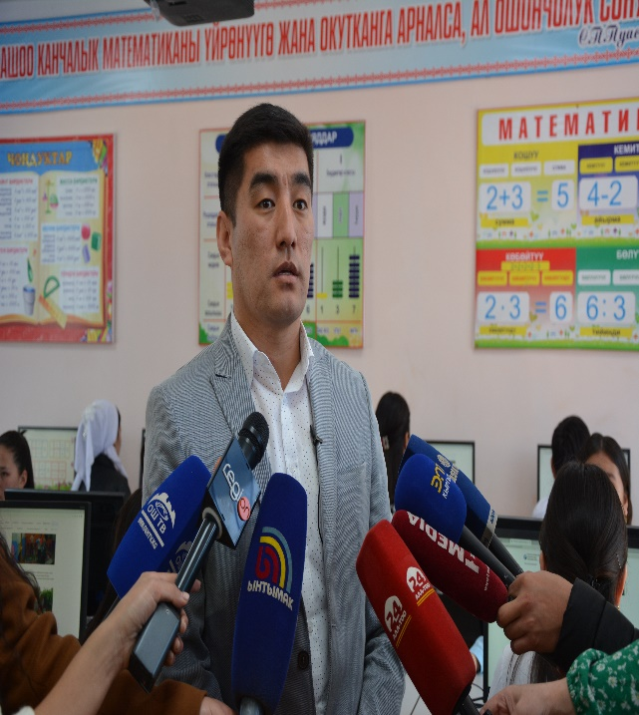
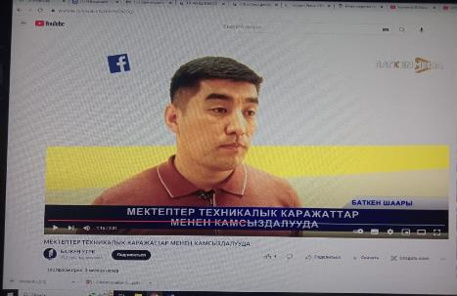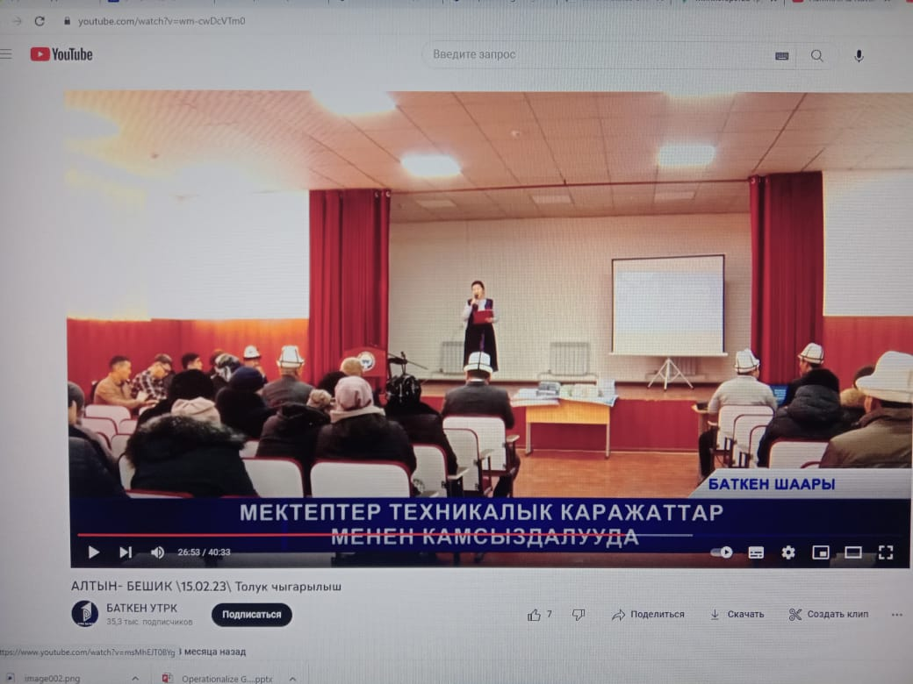
Table 3. Training Plan on social-environmental standards for 2022-2023
Table. Training Plan on social-environmental standards for 2023
№ | Activity | PERIOD | Note
1 | Delivering training for PIU/PCU team, contractor employees, and contractors on the following topics:  - Public Health and Safety Risk Reduction Measures;  - Covid-19 prevention and control recommendations;  - Incident reporting and understanding of Environmental and Social Incident Reporting (ESRI) provisions. | Quarter 2-3, 2023 | Deliver trainings after project staff has been hired and before project activities begin, thereafter in accordance with the project's annual training plans.
2 | Delivering training for PIU/PCU team in:  - WB Social and Environmental Frameworks and Standards;  - Health and Safety Requirements;  - Labor Management Procedures. | Quarter 2-3, 2023 | Deliver trainings after project staff has been hired and before project activities begin, thereafter in accordance with the project's annual training plans.
3 | Delivering training for contracting companies on rehabilitation and restoration work.  (During construction, note the need to take into account the accessibility of infrastructure for people with disabilities (installation of ramp, call button, etc.). | Quarter 2-3, 2023 | After contract with a contracting company is signed.
4 | Insight of contractors into:  - Code of Conduct and SEA/SH risks preventing measures;  - Grievance mechanism for project team and contractors. | Quarter 2-3, 2023 | After contract with a contracting company is signed.

https://edu.gov.kg/organizations/43/pages/206/
https://edu.gov.kg/announcements/200/
Order of the Ministry of Education and Science of the Kyrgyz Republic #1980/1 of 19.11.2021 "On approval of the Regulation on criteria for selection of 60 short-term (3-hour) stay preschool education centers in the Kyrgyz Republic"
See the Operational Manual of the Enhancing the Foundation of Learning project. Paragraph III / Mechanisms of project implementation, page 15
https://edu.gov.kg/organizations/43/posts/602/
https://edu.gov.kg/organizations/43/posts/657/
See Quarterly report of Enhancing the Foundation of Learning Project Q1-3 of 2022
https://edu.gov.kg/legislations/?kind=&direction=&organization=43&number=&title=&content=
https://edu.gov.kg/organizations/43/pages/206/
World Bank Project Implementation/Coordination Unit Order No.01/87 of 22.11.2022 “On approving PIU/PCU Code of Conduct and Ethics”.
https://edu.gov.kg/legislations/?kind=&direction=&organization=43&number=&title=&content=
https://edu.gov.kg/organizations/43/pages/240/

