THE KYRGYZ REPUBLIC

Ministry of Education and Science

Quarterly report
Enhancing the Foundation of Learning Project

Quarter 3, 2023

October-2023

INTRODUCTION

1. Background
In 2018, the President of the Republic approved the ‘National Development Strategy for 2018-2040 (Strategy 2040). Its focus is to create opportunities for human capital development including through education and the creation of highly-productive quality jobs, particularly in strategic sectors. It is fully aligned with the Sustainable Development Goals (SDGs). The first phase of the Strategy 2040, the ‘Development Program of the KR 2018-22 (Program 22)’ acknowledges that the education system is not yet effective in developing the higher order skills that are needed; and identifies several education sector priorities, including: (i) improving the quality of education; (ii) making the education system more effective in teaching skills required by the modern economy; (iii) supplying schools with a broader range of modern teaching-learning materials and innovative technology and (iv) strengthening the professional capacities of teachers. In the latest development, the MoES’s draft of the National Education Sector Strategy 2030 addresses on the following priorities: (i) expanding access to ECE and improving its quality; (ii) strengthening teacher professional capacities to effectively teach skills, including transversal competencies (such as digital literacy) and providing flexible, accessible and affordable continuous professional development; (iii) improving the availability and use of digital teaching-learning materials at schools; and (iv) strengthening assessment systems to ensure children are formatively assessed, summative assessments are aligned with curricular competencies, and sample-based learning outcome evaluations are carried out to identify and remedy system weaknesses.
This report describes the social and environmental activities of the project from July to September 2023.
Environmental and social issues include activities undertaken to manage and minimize adverse environmental and social impacts during implementation of sub-projects of the Enhancing the Foundation of Learning project. In accordance with the environmental and social standards of the World Bank, the procedures and mechanisms necessary for the implementation of appropriate project activities to the standards of the WB, as well as the legal and regulatory acts of the Kyrgyz Republic are covered.
Basis and date of entry into force of the Enhancing the Foundation of Learning Project – The Kyrgyz Republic and the International Development Association signed the Loan Agreement for the Enhancing the Foundation of Learning Project dated July 13, 2021, this Agreement was ratified by the Zhogorku Kenesh of the Kyrgyz Republic on July 29, 2021.
1.1. Project Description
The project objective is to increase equitable access to pre-school education, and to establish conditions for improving its quality. The pre-school institution and its enabling environment are at the core of the project. The project will use a multi-pronged approach that includes three components and several sub-components, as described below.
The pre-school institution and its enabling environment are at the core of The Project. It has two complementary components, as well as an implementation support component.
The first component focuses on enhancing access to quality pre-school education, targeting the poor and vulnerable including minority ethnic groups and children with special education needs. The second component focuses on improving policy, programs and system effectiveness. Successful implementation of these two components would eventually contribute to improved learning outcomes of basic schooling for all.
The third component finances advocacy and communication efforts, monitoring and evaluation and the operating cost to support implementation.

The project consists of 3 components and 5 sub-components.

Component 1: Expanding preschool education for under-served children. The aim of this component is to increase equitable access to early education services that meet quality standards for under-served children in targeted communities.
Sub-component 1.1: Expanded preschool education. The objective of this sub-component is to increase equitable access to quality ECE in poor rural areas with no or low access through establishing CbKs and enhance the effectiveness of teaching-learning practices in preschool. The project will support the establishment of about 60 new CbKs enrolling approximately 5,000 children aged 3–5 years.
Sub-component 1.2: Increased effectiveness in teaching practice. The objective of this subcomponent is to increase teacher capacities in preschool education through the strengthened design and delivery of teacher training programs aligned to the recently approved child development standards and evidence from the science of learning.

Component 2: Improving policy & finance for the system effectiveness. The objective of this component is to improve policy and system effectiveness.

Component 3: Ensuring citizens’ engagement and implementation support.
The objective of this component is to ensure that all stakeholders are engaged in project implementation and monitoring.
Sub-component 3.1: Stakeholders’ engagement. Stakeholders will be engaged in the implementation of activities across the project, building on the mechanisms already in place to involve parents, particularly fathers, and community members. Specifically, this includes: (a) the provision of information for parents on importance of early development of children, story books reading through leaflets, posters, guidance on story books reading importance and techniques, etc.; and (b) community monitoring through community scorecards.
Sub-component 3.2: Evaluation. To assess the project impact, an evaluation using Randomized Control Trials (RCT) will be conducted to determine if participation in the project supported CbKs had an impact on child development.
Sub-component 3.3: Implementation support. This component will support the coordination, technical quality and fiduciary integrity, compliance with environmental and social standards in due course of implementation, as well as the monitoring, evaluation and reporting on project processes and results. It will also support systems for collecting beneficiary feedback to inform project implementation.
2. MONITORING AND REPORTING

The Enhancing the Foundation of Learning project focuses on monitoring and reporting according to approved project implementation plans, compliance with socio-environmental standards, stakeholder engagement plan, labor management procedures, socio-environmental commitment plan, environmental and social management plan, grievance mechanisms, and sexual exploitation and abuse/sexual harassment.
During the reporting period, no incidents or accidents within the framework of the Enhancing the Foundation of Learning project were reported.

3. LEGAL AND REGULATORY ACTS ADOPTED AS PART OF THE IMPLEMENTATION OF THE ENHANCING THE FOUNDATION OF LEARNING PROJECT
3.1. In order to achieve the goals and objectives of the Enhancing the Foundation of Learning project, the following legal and regulatory documentation was prepared and adopted:
- Order of the Ministry of Education and Science of the Kyrgyz Republic #1980/1 of 19.11.2021 "On approval of the Regulation on criteria for selection of 60 short-term (3-hour) stay preschool education centers in the Kyrgyz Republic";
- Order of the Ministry of Education and Science of the Kyrgyz Republic #397/1 of 18.03.2022 "On formation of the permanent commission on selection of community-based kindergartens/preschool education centers";
- Order of the Ministry of Education and Science of the Kyrgyz Republic #398 of 18.03.2022 "On introducing amendments to the Regulation on criteria for selection of 60 short-term (3-hour) stay preschool education centers in the Kyrgyz Republic";
- Order of the Ministry of Education and Science of the Kyrgyz Republic #1429/1 of 14.07.2022 "On approval of the preliminary list of newly selected buildings for establishment of 60 community-based kindergartens/preschool education centers";
- Order of the Ministry of Education and Science of the Kyrgyz Republic #1303/1/1/1 of 01.07.2022 "On accounting of inventories" including quality control of inventories to ensure the safety of children;
- Grievance mechanism for Projects Coordination Unit (PCU) staff and contract specialists approved by the Deputy Minister of Education and Science of KR;
- Order of the World Bank Projects Implementation/Coordination Unit #01/87 of 22.11.2022 "On Approval of the Code of Business Conduct and Ethics of PIU/PCU".

3.2. Incidents and Accidents Notification
Component 1. Expanding preschool education for under-served children.
For the reporting period:
- As of this period during the project implementation, the repair and rehabilitation works in 29 (twenty-nine) CbKs are close to be finalized.
- Upon completion of the second tender, repair and rehabilitation for 14 (fourteen) CbKs have been started.
- Seventeen (17) sites are under re-tender at this moment (Annex 1).
- There are no notifications of incidents and accidents in the current period.

Component 3. Ensuring citizens’ engagement and implementation support.
During the reporting period, lists of kindergarten teachers, quantitative lists of children from socially vulnerable groups, as well as social, gender information, language of instruction of children in CbKs have been prepared (see paragraph ESS 10: Stakeholder Engagement and Disclosure of Information).

4. ESS 1: ENVIRONMENTAL AND SOCIAL RISK AND IMPACT ASSESSMENT AND PREVENTION:
To ensure the implementation of the project in accordance with the Environmental and Social Commitment Plan, socio-environmental standards and other environmental and social instruments, a number of activities were conducted during the reporting period.
4.1. Organizational structure
Within the framework of the project implementation, joint work is performed of coordinators, social specialist, environmental specialist, engineer of the Enhancing the Foundation of Learning Project of WB’s PIU/PCU under the Ministry of Education and Science of the Kyrgyz Republic.
  - Selection mechanisms
According to the criteria for selecting buildings for the establishment of 60 (CbKs), priority areas (cities/towns) for selection and participation in the project are:
- areas (small towns) with low income;
- areas (small towns) with a low level of enrollment of children in preschool education;
- border, high-mountain and remote areas (small towns) with low incomes and coverage of children with preschool education;
- areas (small towns) inhabited by ethnic minorities, internal and external migrants.
The categories of children in the CbKs will include representatives from socially vulnerable groups of the population, specifically: children of parents with disabilities, disabled children, children from single-parent/poor households with limited opportunities for education, children of migrants and ethnic minorities, representatives of families living in isolated and border areas.

4.3. Transparent procedures and processes for selecting communities to engage in the project have been developed and implemented:
- Premises (based on schools, kindergartens, village first-aid stations (FAPs), clubs, offices, etc.);
- Documents of title for the provided building (technical passport, document of title);
- Letter of guarantee from aiyl okmotu addressed to the Minister stating that the provided premises will be used for 10 years;
- Letter from the regional state administration addressed to the Minister stating that they support this project and agree to participate in this project;
- Letter of guarantee from the regional educational departments stating that the salaries of future teachers will be included in the republican budget;
- Number of out-of-school children from 3 to 7 (waiting in line);
- Consent of the sanitary and epidemiological station (to the opening a kindergarten in provided premise/building);
- Consent of the Ministry of Emergency Situations (documentary evidence);
- Photos of the premises.

In total, out of 90 applications throughout the country, 60 CbKs were selected according to the above criteria(Table 2):
In accordance with the procedures for tenders for the repair and rehabilitation, the bids submitted for the tender are systematically evaluated and the final list of all 60 facilities is adjusted.

4.4. Principles of environmental and social management
In Q3 2023, screening was conducted (Table 3) at facilities in Talas oblast (Picture 1).

4.5. Environmental and social screening and ESMP
During the reporting year, 5 online (via phone and WhatsApp messenger) consultations of heads and staff of educational departments in Osh, Issyk-Kul and Talas oblasts have been conducted regarding the application of environmental and social standards in the process of designing facilities, monitoring of construction of the short-term-based kindergartens, providing the lists of teachers and children from the socially vulnerable population.
In the framework of the Enhancing the Foundation of Learning project, drafting the ESMPs for facilities in accordance with the project implementation plan is underway.
1. As per the outcomes of the first tender, 29 ESMPs have been placed on the ministry website;
2. As per the outcomes of the second tender, 14 ESMPs have been placed on the ministry website (Ak-Suu – 4 ESMPs, Aitmatov – 2 ESMPs, Manas – 4 ESMPs, Chatkal and Aksuu rayons - 4 ESMPs).

5. ESS 2: HUMAN RESOURCES AND WORKING CONDITIONS
The Enhancing the Foundation of Learning project is implemented in accordance with regulations and, in particular, labor management procedures adopted and approved by the World Bank, in order to meet socio-environmental standards.
5.1. Human resources management procedure
During the reporting period, the Code of Business Conduct and Ethics of the World Bank Project Implementation and Coordination Unit of the Ministry of Education and Science of the Kyrgyz Republic was signed by:
- 21 PCU employees of the Enhancing the Foundation of Learning Project and is included in the employment contract as an annex.
- The Code of Business Conduct and Ethics was signed by contractual employees of the Enhancing the Foundation of Learning project and representatives of the following companies: Baker Tilly Bishkek LLC, AC consulting, EDNET, Archivision, Consulting Company "Expertise and Technical Supervision", Asia Progress Group LLC, Chyngyz International LLC and Beishembai Kurulush LLC, Zhyrgal Stroy LLC and Dream Stroy LLC, Inkom Systems LLC and Sniper LLC.

5.2. Project staff training
According to the implementation of environmental and social commitment plan, information, implementation of the project and in order to conduct trainings for PIU/PCU key staff members, contract specialists and contractors the collection of information materials to do a presentation and videos on social issues (information on safety, health, health safety, prevention of gender-based violence and discrimination, first aid, labor relations, COVID 19) was completed.
During the reporting period it has been prepared:
1. Animation for PCU contractors and employees on safety and requirements for contractors and employees implementing repair and rehabilitation in CbKs;
2. Animation for PCU contractors and employees on COVID-19 prevention;
3. Animation for PCU contractors and employees on the Code of Business Conduct of the PCU;
4. Presentations according to the Grievance and COVID-19 Prevention Mechanism.
Training for contractors on safety practices, PCU code of business conduct, grievance mechanisms, COVID-19 prevention are being conducted across the board.

6. GRIEVANCE MECHANISM
6.1. Grievance mechanism of the key employees
The project applies a system to ensure feedback from the project beneficiaries, citizens of the Kyrgyz Republic, the public and dissemination of all information related to the project, the proper consideration of complaints and responses and their reporting.
Staff of WB PIU/PCU, contract specialists, employees of REDs, local authorities, directors of schools and community-based kindergartens under the Learning for Future and Enhancing the Foundation of Learning projects are informed about the grievance mechanisms (GMs) and also about protection against retaliation or abuse of power by the employer.
Abovementioned employees have the opportunity to file a complaint or suggestion about the progress of construction, environmental and social protection activities, complaints and concerns related to COVID-19, sexual exploitation and abuse (SEA)/sexual harassment (SH), gender-based violence through the following channels:
- Oral and written referrals during meetings between PIU/PCU staff and stakeholders;
- By telephone: + 996 312 31 70 16;
- Through WhatsApp: +996 777 555 882;
- By fax: +996 312 31 70 16;
- By e-mail: officeorp@gmail.com;
- Project sub-site: www.edu.gov.kg/organizations/43/posts;
- Postal correspondence: Bishkek, Manas Ave. 22 A
6.1.1. Grievance Mechanism for key staff of PIU/PCU and Grievance Mechanism were developed in accordance with the stakeholders, approved by the Deputy Minister of Education and Science of the Kyrgyz Republic, posted on the website of the MES KR.

6.1.2. No complaints have been received from the PCU key employees until now.

6.2. SEA/SH risk mitigation:
In order to mitigate the risks of sexual exploitation and abuse/sexual harassment, awareness-raising activities have been carried out among WB PIU/PCU and contracted professionals.
The Code of Business Conduct and Ethics has been drafted and approved by the order of the WB PCU under the Ministry of Education and Science of the Kyrgyz Republic.
The Code is signed by all Enhancing the Foundation of Learning project staff and thereafter the signed document was included in the employment contract of employees. The Code reflects the norms of behavior of employees in everyday life, at work and obligations to avoid sexual exploitation and abuse, as well as sexual harassment.
No violations of the Code of Conduct and Ethics and no complaints have been registered to date.

7. ESS 10: STAKEHOLDER ENGAGEMENT AND INFORMATION DISCLOSURES

The overall objective of this Stakeholder Engagement Plan (SEP) is to define a program of stakeholder engagement, including public information and consultation, during the preparation and implementation of the proposed project. The SEP outlines ways to identify potential different stakeholders, develop an approach to reach each sub-group, establish a mechanism through which Project Affected Parties (PAPs) and other stakeholders can report concerns, provide feedback or complaints, and minimize and mitigate environmental and social risks associated with the proposed project.
Overall, the SEP serves the following objectives: (i) identification and analysis of stakeholders; (ii) planning of engagement forms, effective communication tools for consultation and disclosure; (iii) provision of platforms to influence decisions; (iv) identification of roles and responsibilities of various actors in implementing the Plan; and (iv) grievance mechanism (GM).
The Stakeholder Engagement Plan was adopted and endorsed by the World Bank and published on the MES website.
Based on the requirements of the SEP and during the reporting period, the following activities were carried out:

7.1. Prepare and implement a stakeholder engagement plan.
As part of the implementation of the Enhancing the Foundation of Learning project, the various project stakeholders are being involved, starting with the conceptual stage of the project.
7.1.1. The following types of stakeholder engagement activities have currently been implemented:
- A meeting held with heads and coordinators of REDs of Manas, Aitmatov, Bakai-Ata, Talas rayons of the Talas oblast on the prioritization of inclusion of children from socially disadvantaged groups in the teaching in CbK (Picture 2);
- Instruction on acceptance of material and technical values for 60 CbKs was finalized, coordinated and approved by the PCU management; information disseminated to 46 coordinators of REDs;
- A letter and instruction for RED coordinators on preparing a list of teachers to participate in trainings was prepared. Consultations were held with the heads and coordinators of REDs (46 rayons and cities of the country) on the correct submission of lists of teachers. Lists of teachers for participation in trainings from 46 rayons and cities were summarized and submitted to coordinators Isaeva A.A., Mamytova G.K.;
- A letter and instructions for preparing a list of children from socially disadvantaged groups were drafted. Consultations were held with the heads and coordinators of REDs (46 rayons and cities) on the submission of lists of children from socially disadvantaged groups of the population to be taught in CbKs. Lists of children from socially disadvantaged groups from 46 rayons and cities summarized and submitted to the coordinator Isaeva A.A.
7.1.2. During the trip to the Talas oblast, the RED coordinators were provided with information on the Enhancing the Foundation of Learning project and the Grievance Mechanism.
7.1.3 In order to give the public insight into the results of the work done and the implementation of the Stakeholder Engagement Plan, photos of CbK screenings, meetings with stakeholders, informational materials (explanatory animation, presentations) have been posted.

7.2. Grievance Mechanism

7.2.1. An electronic GM log for registration of incoming complaints has been drafted and kept. For Q3 of 2023 there were no complaints, 2 proposals received. During this period of the project implementation, appeals are mainly of advisory and informational nature related to the preparation of lists of children from socially vulnerable groups, participation of teachers in trainings, start of construction works on the establishment of CbKs (Picture 3).

7.2.2. GM and informational materials provided to the REDs of the Talas oblast (Aitmatov, Bakai-Ata, Manas, Talas rayons) for further dissemination among the kindergarten staff and local population.

7.3 According to the Stakeholder Engagement Plan, 5 consultations on GM were provided during meetings with representatives of Aiyl Okmotu, heads and staff of regional educational departments, school and kindergarten directors, socially vulnerable groups of population (Chui oblast – 2, Talas oblast – 3).

8. CAPACITY BUILDING (TRAINING)
Capacity building and trainings delivering take a special place in the awareness of stakeholders, PCU staff, contractual staff, contractors, due to the need to be informed about the legal and regulatory documents of the Kyrgyz Republic, the World Bank's environmental and social standards, GM, Code of Business Conduct and Ethics and other documents.
- Trainings on ESS are delivered for the PCU staff and contracting companies;
- The meeting in the World Bank office on the implementation of the Enhancing the Foundation of Learning project under the GPE Mission was attended.

9. IT IS SCHEDULED:
Based on the annual plan, the following types of activity are scheduled to be conducted by the WB PCU staff in the next reporting period in Q4 of 2023:
9.1 Further approval and draft of ESMPs for 60 sites;
9.2 Further insight of contractual staff into the Code of Conduct and Ethics;
9.3. Arrangement of trainings for PCU staff, contractual staff, contractors involved in the Project implementation on topics according to the plan (Table 4).
9.4 Monitoring of construction works at the facilities by oblast.

Annex to the report:

Annex: Table 1. Repair and rehabilitation realization stages

Condition of the operational CbK facilities in the northern and southern regions as of 02.10.2023
Enhancing the Foundation of Learning Project, 60 CbKs following the Tender 1 (29 facilities)

Condition of the operational CbK facilities in the northern and southern regions as of 02.10.2023
Enhancing the Foundation of Learning Project, 60 CbKs following the Tender 2

Condition of the operational CbK facilities in the northern and southern regions as of 02.10.2023
Enhancing the Foundation of Learning Project, 60 CbKs (re-tender)

Annex: Table 2. Selected premises for the establishment of CbKs
№ | Region | Number of buildings | Number of children
 | Naryn | 3 | 218
 | Kochkor | 2 | 155
 | Ak-Suu | 4 | 230
 | Jeti Oguz | 1 | 100
 | Ton | 0 | 0
 | Yssyk-Ata | 2 | 170
 | Kemin | 2 | 180
 | Moskowsky | 1 | 75
 | Panfilov | 2 | 350
 | Kara-Buura | 9 | 677
 | Manas | 3 | 208
 | Talas city | 0 | 0
 | Toktogul | 0 | 0
 | Bazar-Korgon | 5 | 210
 | Nooken | 2 | 100
 | Suzak | 4 | 210
 | Aksy | 2 | 166
 | Chatkal | 2 | 100
 | Alay | 3 | 150
 | Nookat | 2 | 100
 | Aravan | 5 | 150
 | Kara-Kulja | 2 | 100
 | Batken | 2 | 160
 | Leilek | 2 | 120

Annex: Table 3. Screening conducted
No. | Oblast | No. of facilities of the project
1 | Talas | 12

Annex: Picture 1. Facility monitoring in Talas oblast
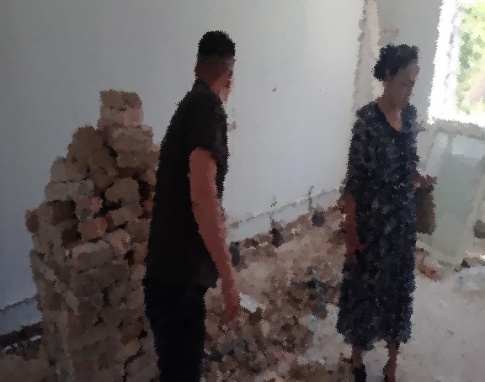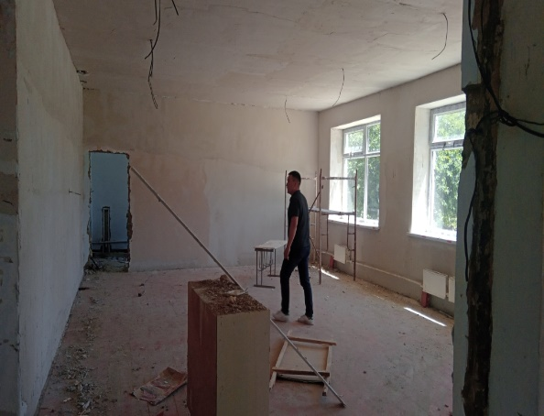
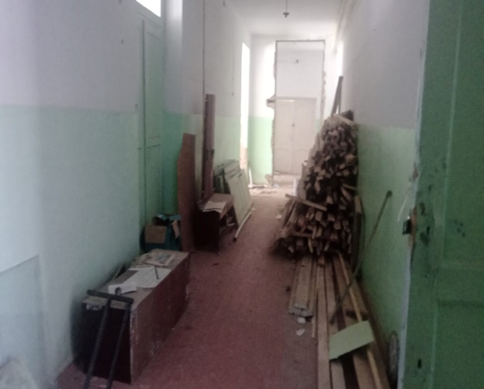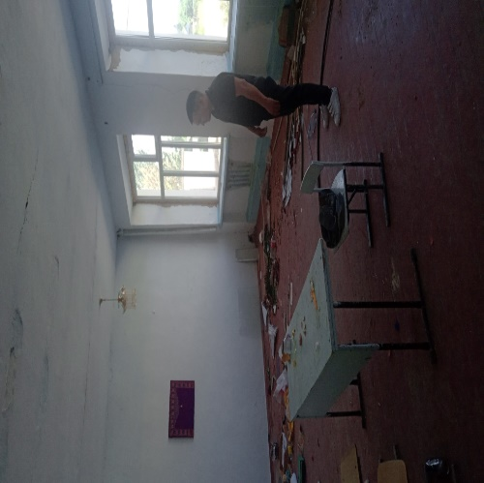

Annex: Picture 2. Awareness raising campaign and meetings with the heads of REDs, Talas oblast
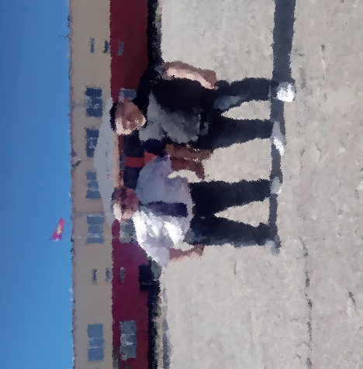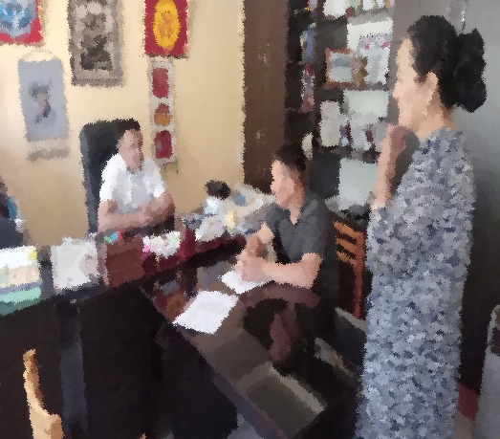

Annex: Picture 3. Recorded appeals as part of GM

Annex: Table 3. Environmental and Social Standards Training Plan for 2023
№ | Activity | PERIOD | Note
1 | Delivering training for PCU team, contractual employees, and contractors on the following topics:  - Public Health and Safety Risk Reduction Measures;  - Covid-19 prevention and control recommendations;  - Incident reporting and understanding of Environmental and Social Incident Reporting (ESRI) provisions. | Quarter 2-3, 2023 | Deliver trainings after project staff has been hired and before project activities begin, thereafter in accordance with the project's annual training plans.
2 | Delivering training for PCU team in:  - WB Social and Environmental Frameworks and Standards;  - Health and Safety Requirements;  - Labor Management Procedures. | Quarter 2-3, 2023 | Deliver trainings after project staff has been hired and before project activities begin, thereafter in accordance with the project's annual training plans.
3 | Delivering training for contracting companies on rehabilitation and restoration work.  (During construction, note the need to take into account the accessibility of infrastructure for people with disabilities (installation of ramp, call button, etc.). | Quarter 2-3, 2023 | After contract with a contracting company is signed.
4 | Insight of contractors into:  - Code of Conduct and SEA/SH risks preventing measures;  - Grievance mechanism for project team and contractors. | Quarter 2-3, 2023 | After contract with a contracting company is signed.

https://edu.gov.kg/organizations/43/pages/206/
Order of the Ministry of Education and Science of the Kyrgyz Republic #1980/1 of 19.11.2021 "On approval of the Regulation on criteria for selection of 60 short-term (3-hour) stay preschool education centers in the Kyrgyz Republic"
See the Operational Manual of the Enhancing the Foundation of Learning project. Paragraph III / Mechanisms of project implementation, page 15
https://edu.gov.kg/organizations/43/posts/602/
https://edu.gov.kg/organizations/43/posts/657/
https://edu.gov.kg/organizations/43/pages/252/
https://edu.gov.kg/legislations/?kind=&direction=&organization=43&number=&title=&content=
https://edu.gov.kg/organizations/43/pages/206/
World Bank Project Implementation/Coordination Unit Order No.01/87 of 22.11.2022 “On approving PIU/PCU Code of Conduct and Ethics”.
https://edu.gov.kg/legislations/?kind=&direction=&organization=43&number=&title=&content=
https://edu.gov.kg/organizations/43/pages/253/

